Hi John and Manatt.  I’ve been looking for a graphic on the vision or goal of the future data exchange landscape.  Thus far I can only find in the  material scenarios of gaps and problems.  Does a draft vision graphic exist of the DxF’s goal?

I had expected to see the goal within the document referenced below.   I have looked thru various other material from [https://www.chhs.ca.gov/data-exchange-framework/#stakeholder-advisory-group-past-meeting-materials](https://gcc02.safelinks.protection.outlook.com/?url=https%3A%2F%2Fwww.chhs.ca.gov%2Fdata-exchange-framework%2F%23stakeholder-advisory-group-past-meeting-materials&data=05%7C01%7CCDII%40chhs.ca.gov%7C07035fbffd164955388c08da47daeded%7C95762673f4ed4bb6ac42439d725bf5e8%7C0%7C0%7C637901303054416009%7CUnknown%7CTWFpbGZsb3d8eyJWIjoiMC4wLjAwMDAiLCJQIjoiV2luMzIiLCJBTiI6Ik1haWwiLCJXVCI6Mn0%3D%7C3000%7C%7C%7C&sdata=0pBSitUirNB0N6ICQTWNGtnq6J9FTAXyqCkir7BLLJI%3D&reserved=0).

An example of what I am not looking for from [https://www.chhs.ca.gov/wp-content/uploads/2022/05/4_CalHHS_DxF_Data-Exch-Scenarios_Revised_Draft_5-12-2022.pdf](https://gcc02.safelinks.protection.outlook.com/?url=https%3A%2F%2Fwww.chhs.ca.gov%2Fwp-content%2Fuploads%2F2022%2F05%2F4_CalHHS_DxF_Data-Exch-Scenarios_Revised_Draft_5-12-2022.pdf&data=05%7C01%7CCDII%40chhs.ca.gov%7C07035fbffd164955388c08da47daeded%7C95762673f4ed4bb6ac42439d725bf5e8%7C0%7C0%7C637901303054416009%7CUnknown%7CTWFpbGZsb3d8eyJWIjoiMC4wLjAwMDAiLCJQIjoiV2luMzIiLCJBTiI6Ik1haWwiLCJXVCI6Mn0%3D%7C3000%7C%7C%7C&sdata=qT%2BDru3V6KSYYlvtml5wdtLdfK%2BB5pw0j%2FWLpxaHFGA%3D&reserved=0)

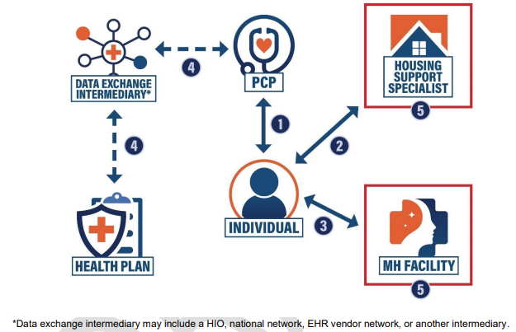

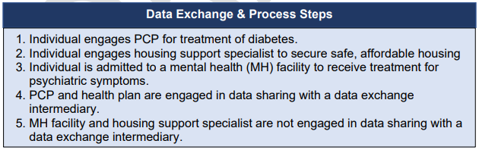

**DeeAnne McCallin**

Director of Health Information Technology

**California Primary Care Association**