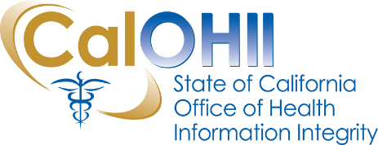
CalOHII Communications
September 2021
In this month’s communication, the California Office of Health Information Integrity (CalOHII) provides updates regarding CalOHII activities and news from the federal Health and Human Services (HHS).
CalOHII Updates
- State Health Information Guidance (SHIG) – the SHIG project is moving forward on various efforts – brief updates on each SHIG topic follow:
  - SHIG 3.0 Sharing HIV/AIDS Information in California – we are proud to announce the publication of SHIG 3.0 in mid-July. This volume of SHIG includes four (4) scenarios to support coordination of care for people living with HIV/AIDS. The newest volume of SHIG can be found on the SHIG webpage.
  - Upcoming volumes of SHIG – the CalOHII team continues to work with Advisory Committee members on the following topic areas:
    - SHIG 4.0 Sharing Health Information of People Living with Intellectual and/or Developmental Disabilities in California – Final document is in last internal review at CalOHII, target publication date is mid-September.
    - SHIG 5.0 Sharing Minors and Foster Youth Health Information in California – the last SHIG Advisory Group meeting is September 8th to finalize content of materials. The target publication date is mid to late September.
- Statewide Health Information Policy Manual (SHIPM) – feedback and requests for revisions to the current SHIPM volume may be sent to OHIComments@ohi.ca.gov
- Universal Authorization – the draft universal authorization form has been finalized for stakeholder review and comments. We continue working with other state departments to pilot the draft form and solicit comments/feedback.
- HIPAA Compliance – CalOHII continues to work with four (4) departments on their Corrective Action Plan (CAP) action items as well as conducting a Targeted Review with a large department.
- State Legislation Review – CalOHII has reviewed over 470 bills for possible SHIPM or SHIG, and Compliance Program impacts – at this time we are actively tracking one bill and watching 6 bills.
- Incident/Breach – CalOHII continues to review and follow-up with organizations regarding incidents reported to CalCSIRS.
- Technical Assistance – CalOHII continues to provide information to organizations and individuals with questions concerning the privacy protections of health information in California.

HHS News
- ONC has retired the Health IT Dashboard – they have launched the all-new HealthIT.gov/Data. Visit the site to see updated features such as recent data briefs available in web text, a refreshed design, new data visualizations and more! This area can be accessed from the main navigation on HealthIT.gov or visiting HealthIT.gov/Data.
Contact Us…
If you have any questions or comments about the content of this newsletter, contact us at OHIComments@ohi.ca.gov.

Past CalOHII Communications are on the CalOHII Communications - Archive page.

