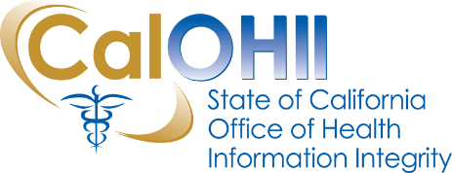
CalOHII Communications

July 2020
For this month’s communications, our focus is on providing updates from the federal Health and Human Services (HHS) related to the COVID-19 emergency as well as updates on CalOHII activities. We are keeping our website up-to-date as state and federal guidance is made available. Please keep an eye on our home page for the most recent updates.
CalOHII Updates
- COVID-19 Support – CalOHII continues to support various state initiatives regarding the privacy of protected health information.
- 2020 State Health Information Guidance (SHIG - version 2) Update – CalOHII conducted a kick-off meeting in June with more than 40 stakeholders representing health providers and providers of nutrition and food services, both public and private. We captured the participant’s questions as a “Questions and Answers” document on the SHIG page. In July, we will begin conducting working sessions to gather information about organization’s barriers to health information sharing to support the development of use cases.
- Risk Analysis/Risk Assessment Focused Review – CalOHII is finalizing results of the focused review for communication to participating departments in July.
- HIPAA Compliance - CalOHII continues to work with two (2) departments on their final Corrective Action Plan (CAP) documentation as well as two (2) departments on completing their CAP items.
- State Legislation Review – CalOHII is actively tracking four (4) bills and watching an additional 36 bills that could impact the Statewide Health Information Policy Manual (SHIPM). During this session, CalOHII reviewed over 340 bills for potential health information or SHIPM impacts.
- Incident/Breach – CalOHII continues to review and follow-up with organizations regarding incidents reported to CalCSIRS.
- Technical Assistance – CalOHII continues to provide information to organizations and individuals with questions concerning the privacy protections of health information in California.

HHS News
- HHS and the Office for Civil Rights (OCR) Guidance – OCR issued guidance on how the Health Insurance Portability and Accountability Act (HIPAA) Privacy Rule permits covered health care providers to contact their patients who have recovered from COVID-19 to inform them about how they can donate their blood and plasma containing antibodies to help other patients with COVID-19. More information is on the CalOHII Emergency Information Sharing page.
- HHS and the Division of National Standards (DNS) Guidance - DNS issued a guidance letter to clarify the process for requesting and conducting an exception to the HIPAA transaction and code set standards. The full guidance letter is on the Centers for Medicare and Medicaid Services website.
Contact Us…
If you have any questions or comments about the content of this newsletter, contact us at OHIComments@ohi.ca.gov.

Past CalOHII Communications are on the CalOHII Communications - Archive page.

