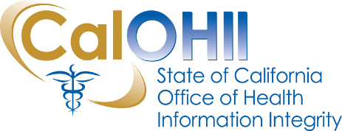
CalOHII Communications

July 2019
In this month’s communication, the California Office of Health Information Integrity (CalOHII) provides updates on CalOHII activities, news from the federal Health and Human Services (HHS) as well as links to various news articles related to the Health Insurance Portability and Accountability Act (HIPAA) and healthcare industry.
CalOHII Updates
- CalOHII Website – we have updated our website to ensure compliance with California Government Code Sections 7405 and 11135. As a result, older versions of Statewide Health Information Policy Manual (SHIPM) and Health Information Exchange (HIE) archive web pages are no longer available. Contact CalOHII (at OHIComments@ohi.ca.gov) if you need any documents that are no longer available.
- Compliance Program – In addition to continued work on compliance reviews and Corrective Action Plans (CAPs), the team is finalizing updates to the Compliance Review tools. The tools are being updated to reflect recent changes in the SHIPM. Updates to the Compliance Review Tool, Artifact Request List, and checklists will be published to the website by the end of July.
- State Legislation Review – CalOHII continues to review and track legislation related to the HIPAA and/or healthcare data privacy. We are tracking 20+ bills that could impact SHIPM 2020 or our Compliance Review program.
HHS News
- Office for Civil Rights (OCR) issued a new Frequently Asked Question (FAQ) clarifying how protected health information (PHI) can be shared by health plans to promote coordination of care.

Other News
- WannaCry is still attacking – 40% of healthcare delivery organizations were attacked in the past 6 months. It appears this is due in part to organizations not applying a Microsoft patch for a flaw in Remote Desktop Services. The full article can be found on the HIPAA Journal website.
- The U.S. Department of Justice announced the indictment of two Chinese Nationals for their part in the Anthem, Inc. hack – this article provides some good insights on how to avoid/prevent these types of hacks. The full article can be found on the Technology Employment Law website.
- House overturns ban on funding national provider ID – the amendment moves to the Appropriations and the Senate for further actions. The full article can be found on the HIPAA Journal website.
Contact Us…
If you have any questions or comments about the content of this newsletter, contact us at OHIComments@ohi.ca.gov.

Past month’s CalOHII Communications can be found on the CalOHII Communications - Archive page.

