Competitive Integrated Employment Blueprint
Region Local Partnership Agreement
Effective Date: 2018

Intent/Purpose
The purpose of the Inland Empire Local Partner Collaborative (IELPC) for Competitive Integrated Employment (CIE) is to enhance collaborative partnerships leading to improvements in the level and quality of services which ultimately promotes the preparation and achievement of CIE for youth and adults with intellectual disabilities/developmental disabilities (ID/DD). Following effective collaboration with those core partners referenced within this agreement, the intent is to have local partnership agreements (LPA) for the Inland region developed and implemented by each Department of Rehabilitation - Inland Empire District (IED) office.

Identification of Core Partners
Core partners composing the IELPC include the IED, local education agencies (LEA), and the Inland Regional Center (IRC).

Exhibit C -- Core partner information

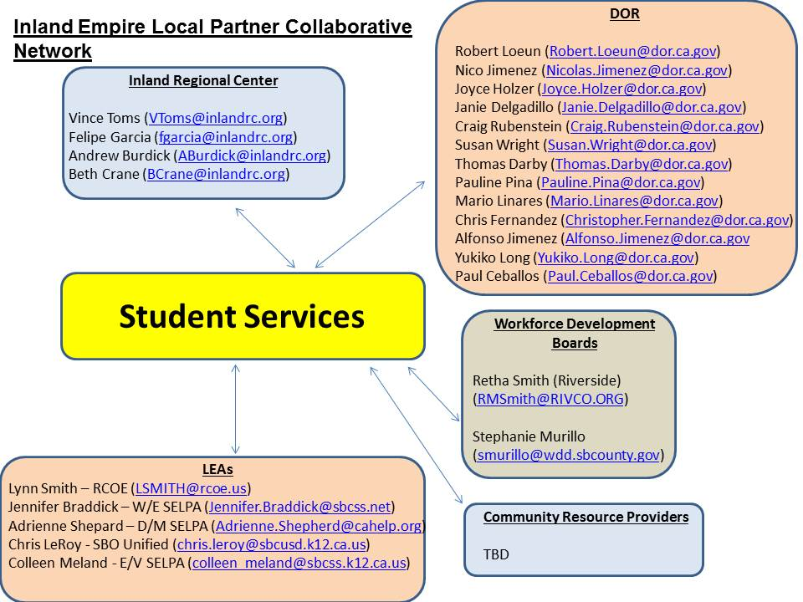

DOR Inland Empire District (IED) - Team Managers:
- Robert Loeun DA, District Office
- Paul Ceballos TM, District Office
- Chris Fernandez TM, District Office
- Mario Linares TM, District Office
- Craig Rubenstein TM, District Office
- Alfonso Jimenez TM, District Office
- Joyce, Holzer TM, Temecula Office
- Nicolás Jimenez TM, El Centro Office
- Pauline Pina TM, Ontario Office
- Thomas Darby TM, San Bernardino Office
- Janie Delgadillo TM, Palm Desert Office
- Susan Wright TM, Victorville Office
DOR Contact Info:
Inland Empire District Office: 2010 Iowa Ave., Ste 100, Riverside, CA 92507; (951) 782-6650

Local Education Agencies (LEA) - CaPROMISE Core Partners:
- Riverside County Office of Education: Lynn Smith
- West End SELPA: Jennifer Braddick
- Desert Mountain SELPA: Adrienne Shepherd
- San Bernardino City Unified School District: Chris LeRoy
- East Valley SELPA: Colleen Meland

Inland Regional Center (IRC) Core Partners:
- Vince Toms, Community Services Director
- Felipe Garcia, Children’s and Transition Director
- Andrew Burdick, Employment Specialist
- Beth Crane, Employment Specialist
IRC Contact Info:
Inland Regional Center: 1365 S. Waterman Ave, San Bernardino, CA 92408; (909) 890-3000

San Bernardino and Riverside Counties Workforce Development Board Partners:

This LPA is consistent with the AJCC System Memorandums of Understanding (MOU), effective on the 1st day of January 2018, and entered into by the Riverside County and San Bernardino County Workforce Development Boards (WDB) and the DOR, along with their respective partners.

The MOUs, in each respective county, created a partnership to provide comprehensive, integrated workforce development services to businesses and jobseekers in the Local Workforce Development Area (LWDA) in accordance with the Workforce Innovation and Opportunity Act (WIOA) and its implementing regulations. This Regional LPA is narrow in scope in that the primary focus is on the promotion of collaboration, and engagement efforts leading to employment outcomes for individuals with ID/DD. In line with these efforts, the WDBs will serve as a resource in effectively engaging and collaborating with current AJCC MOU partners and local businesses.

Moreover, the DOR, WDBs, AJCCs, and community partners will engage in cross-training opportunities to understand how to best serve individuals with ID/DD and share best practices associated with working with this population.

There is a need for employment interventions for individuals with ID/DD that are supported by collaborative agreements, including this Regional LPA, which lead to CIE outcomes for the ID/DD population.
Point of Contacts - WDB:

Retha Smith
Assistant Manager, Administration
EDA Workforce Development (Riverside County)
1325 Spruce Street, Suite 400
Riverside, CA 92507
951.955-2203 Office

Stephanie Murillo
Administrative Supervisor 1
San Bernardino County Workforce Development Department
290 North D Street, Suite 600

Identification of Community Partners
The IELPC is an amalgamation of organizations and stakeholders who have collectively agreed to participate in and support CIE outcomes and related programs.
In support of these goals, the core partners (DOR, LEA, and IRC) will engage locally with community partner agencies and businesses to establish and maintain distinct LPAs that are commensurate with the needs specific to their catchment area. Moreover, new partners will be added, particularly charter schools, institutions that provide continuing education, and adult education programs to address the individualized educational needs of the consumers served.

Roles and Responsibilities: Collaboration through Person-Centered Processes
Person-centered planning (PCP) is a process-oriented approach to empowering individuals with disabilities. PCP has a primary focus on people and their specific needs by putting them in charge of defining the direction for their lives, not on the systems which may or may not be available to provide services. This ultimately leads to greater individual success and inclusion as valued members of both community and society.

The IELPC will play a critical role in addressing the individualized vocational needs possessed by those within the ID/DD population.
PCP approaches employed by the IELPC will initially focus on Youth with Disabilities (YWD) and Students with Disabilities (SWD) until such time that the IELPC establishes mutually beneficial partnerships with additional LEAs who provide educational opportunities for the adult population over 21 years of age.
PCP services will be provided to YWD and SWD who meet the criteria referenced below.

SWD: Students (Ages 16-21) in secondary school - and who receive services from the following agencies:
- DOR – Inland Empire District
- Inland Regional Center
- LEAs:
Riverside County Office of Education
West End SELPA
Desert Mountain SELPA
San Bernardino City Unified School District
East Valley SELPA

YWD: Individuals (Ages 18–24) and not in secondary school – and who receive services from the following agencies:
- DOR – Inland Empire District
- Inland Regional Center
- LEAs:
Riverside County Office of Education
West End SELPA
Desert Mountain SELPA
San Bernardino City Unified School District
East Valley SELPA

Note: 1200-1400 consumers served by Inland Regional Center annually may need transition planning services.

Referral and Intake Processes

An additional objective of the IELPC shall be to streamline the referral process collectively established between the IRC, DOR, LEAs, and other community partner agencies, including the local WDBs, which provide services to individuals with ID/DD. This LPA shall serve as a framework that can be used by DOR branch offices and LPA core partners (LEAs and IRC) to develop and implement LPAs which address the specific operational needs of their respective catchment areas to support CIE outcomes. Ideally, LPA partners will also continue to reference the finalized AJCC System MOUs for referral processes and remain committed to collaboration and the sharing of resources.
- DOR – Inland Empire District:
Best practice is for all referrals to come through IRC to DOR. The form to be utilized for this purpose is referenced below.

Referral form (succeeding page)
Exhibit A - IRC Referral Form to DOR to be used by IRC CSC

Alternatively, SWDs may be referred to the DOR for VR services by way of placement in a Transition Partnership Program class or through the use of the referral form referenced below.
Exhibit B – Referral Form to DOR to be used by LEA
Exhibit D Referral Form to be used by LEA to IRC
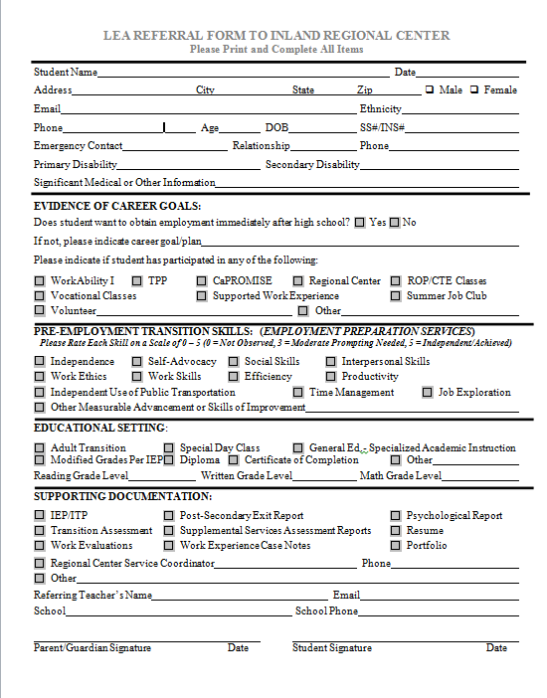

- Service delivery approaches specific to YWD are structured based on whether or not the individual has received LEA transition services prior to DOR referral/application and other factors. Please refer to the flowchart referenced below.

Exhibit A1 – Youth Seeking Subminimum Wage Employment

IRC - DOR referral process – 24 years and under
1. For all consumers 24 years and under, referrals for DOR services will come directly from IRC Consumer Services Coordinators (CSC) or LEA.
2. The Referral Packet is completed by the IRC CSC and sent to the DOR Supported Employment Liaison/Point of Contact for the designated DOR office/unit.
a. Referral Packet to include:
- DOR referral form
- Consent to release information signed by consumer
- IPP
- Social Assessment
- Psychological Assessment
- Medical Assessment
- CDER
- Annual / Case Notes
- DS1968 signed by consumer and IRC CSC
- IEP/ITP
3. It is Important that the IRC CSC has discussed with the consumer/family that a referral has been made to the DOR for employment services.
4. Once the referral is received by the designated DOR Liaison, the consumer will be referred for DOR orientation.
5. A letter will be sent to the consumer with date, time, and location information corresponding with orientation of DOR services. Orientations for are held weekly at each of the local DOR offices. Alternatively, applicants for DOR services may participate in an initial interview.
6. A copy of the orientation appointment letter will be emailed to the IRC CSC.
7. Once the consumer has completed the orientation, a DOR intake session will be scheduled with the consumer.
8. A letter will be sent to the consumer with the intake appointment date, time and location and the name of assigned Qualified Rehabilitation Professional (QRP). Standard Practice: the intake meeting is scheduled within 2 weeks of the consumer attending orientation.
9. A copy of the intake appointment letter will be emailed to the IRC CSC.
10. Once a consumer attends their intake appointment a case will be opened with the DOR to determine eligibility and services.

Eligibility Determination for Core Partners

Inland Regional Center
The assessment process an individual must go through to qualify for IRC services is referred to as “intake.” During this process, IRC will gather social, psychological, and medical information to determine eligibility. The intake process varies slightly depending on the age of the applicant.
Diagnoses that qualify a person for Regional Center services include the following developmental disabilities:
  - Autism
  - Cerebral Palsy
  - Intellectual Disability
  - Epilepsy
  - Conditions closely related to, and requiring treatment similar to intellectual disability
In addition, to qualify for Regional Center services, a person’s developmental disability must:
- originate prior to age 18
- be expected to continue indefinitely
- be a substantial disability, meaning the person experiences significant limitations in three or more of the following areas:
Self-care, language, learning, mobility, self-direction, capacity for independent living, economic self-sufficiency

Department of Rehabilitation
The purpose of the assessment process is to allow the consumer and his/her VR counselor to discuss the following:
- The disability and how it affects the consumer's ability to work.
- The types of DOR services the consumer may need to become employed.
Once the DOR receives complete information about the consumer's disability, the QRP will notify the consumer in writing about eligibility determination.
If the information received is delayed or incomplete, the QRP and consumer can work together to establish an extension date by which eligibility can be determined.
To be eligible for services, an individual must:
- Have a physical or mental impairment that substantially impedes his or her ability to secure employment and vocational rehabilitation (VR) services are required to prepare for, secure, retain, or regain employment consistent with the applicant's unique strengths, resources, priorities, concerns, abilities, capabilities, interests, and informed choice.
- Be able to benefit from DOR services in terms of an employment outcome in an integrated setting.

In the Eligibility process, the consumer and DOR Counselor will:
- Obtain and review medical and other information to determine how the consumer's disability affects your ability to work.
- Determine how DOR services can help consumer establish and maintain employment.

Local Educational Agencies (LEA)
- A parent, teacher or service provider can complete a referral for assessment on behalf of a student at any time, and there are specified requirements as to when an LEA must respond to the referral. An assessment is an evaluation process that usually involves tests, interviews, and observations designed to identify the child’s strengths and evaluate specific issues related to school performance. The assessment results may also identify the types of special education services in line with the needs of students with disabilities. The assessment process may lead to the development of Individualized Education Program (IEP) or 504 Plan.
- The Individuals with Disabilities Education Act (IDEA) is a four-part (A-D) piece of American legislation that ensures students with a disability are provided with Free Appropriate Public Education (FAPE) that is tailored to their individual needs. Appropriate evaluation determines eligibility and establishes a student’s need for special education services. A parent, LEA staff, or service provider can complete a referral for assessment on behalf of a student at any time. The evaluation process involves assessments, interviews, and observations designed to identify the student’s strengths and evaluate specific issues related to school performance.
- There are 13 categories of special education as defined by the Individuals with Disabilities Education Act (IDEA). To qualify for special education, the IEP team must determine that a student fits one of the following categories, and it must adversely affect their educational performance:
- Intellectual Disability
- Hard of Hearing
- Deafness
- Speech or Language Impairment
- Visual Impairment
- Emotional Disturbance Orthopedic Impairment
- Other Health Impairment
- Specific Learning Disability
- Deaf-Blindness
- Multiple Disability
- Autism
- Traumatic Brain Injury

- When determining eligibility for special education, the team must first identify the area(s) of disability and secondly must determine the need for special education and related services. The assessment process may lead to the development of an IEP or 504 Plan. There must be a direct correlation between the IEP goals and the services provided. Placement and services are determined by the student’s unique needs and IEP goals; not the disability.

Coordinating Person-Centered Planning

DOR – Inland Empire District:
- Person-Centered (PC) planning is an approach to support a person (consumer) towards their preferred future. The preferred future is what the consumer wants to do based on their needs, strengths, resources, priorities, concerns, abilities, capabilities, preferences, life style, cultural background and informed choice. The person centering planning process is an on-going process and not one single meeting. A team of people who know the person best, family, friends and other identified resources of support who can assist the consumer with the planning process and making informed decisions for their preferred future. For example, this can occur during a DOR plan development meeting, when making decisions about the Individualized Plan for Employment, Regional Center during an Individualized Program Plan meeting, and the High School during an Individualized Education Program.
- Customized Employment (CE)-in development
Note: Additional information corresponding to the above-referenced efforts is forthcoming.

Inland Regional Center
Individual Program Plan:
The Individual Program Plan (IPP) is created during a meeting with the consumer and their IRC Consumer Service Coordinators (CSC). Depending on the consumer’s age, their support team can also include family members, teachers, service providers, etc. It is important for all members of the team to remember that the consumer’s choices and goals guide the IPP. The said approach is consistent with PCP.

During the IPP meeting, the team will discuss various aspects of the consumer’s life including, their home life, school/work, medical conditions/needs, behavioral health, daily living skills, and more. These discussions set the stage for the Desired Outcomes section of the IPP, which defines the consumer’s goals for the year. A complete and detailed IPP helps explain and justify the services and supports that the consumer will receive.

Statement on the Person-Centered Process (Summary of career pathways):
- The cornerstone of our service philosophy is person-centered planning. Every person is different. They have unique needs, support systems, goals, and preferences. Our service plans reflect that individuality. IRC CSCs work together with consumers to create service plans that embody what IRC believes in: consumer independence, empowerment, and inclusion.

IRC CSC’s roles and responsibilities in the following categories:

Students in secondary school
Ages 16-17:
  - Evaluate consumer progress and plan as identified in IPP on an ongoing basis.
  - Assure Individual Transition Plan (ITP) is included in IEP and attend IEP meetings.
  - CSC’s need to familiarize themselves with consumer strengths, career goals regarding work or pursuing post-secondary education.
  - Determine if consumer is on a diploma or certificate of completion track.
Ages 18-21:
  - Evaluate consumer progress and plan as identified in the IPP on an ongoing basis.
  - Determine if consumer is to remain in school until age 22 (highly influenced by the track they have been on). This is discussed during IPP development and meetings.
  - If leaving at 18, they are a likely candidate for college or individual placement for work. At this point CSC would refer to DOR for both college and work (assess for CIE).
  - If they remain in school, attend IEP meetings and work with family and consumer on career goals for their eventual completion of school at age 22.
  - Paid Internship Program (PIP)- if they remain in school, CSC at an IEP, should discuss the possibility of referring student to PIP to prepare for CIE after leaving school. School or IRC vendor to provide PIP.

Individuals not in secondary school
Ages 18-21:
- Refer to DOR or college courses- depending on abilities and career goals outlined between ages 16-17 or on current IPP. CSC can also request IRC to fund PIP with an IRC vendor.
Ages 22-24:
- Refer to DOR or post-secondary education - depending on abilities and career goals outlined between ages 16-17 or on current IPP. CSC can also request IRC to fund PIP with an IRC vendor

CSC Expectations:
- Maintain contact with consumers and their families as required.
- Evaluate consumer progress and plan as identified in IPP on an ongoing basis.
- Pursuant to the State Department of Developmental Services (DDS) provide advocacy services to consumer and his family. Give high priority to attending all relevant meetings (i.e. IEP, ITP, IHC) and prepare paperwork and notate the IPP as necessary.
- Seek out and effectively utilize generic resources on behalf of consumers. Provide information and referral services.
- Coordinate transportation services at any stage once complete or exited from school

LEAs:
Ages 18 – 21:
Students can participate in Adult Transition Program funded by their school district if they have an IEP and have not graduated with a diploma. Such programs focus on community based instruction and often include an emphasis on independent living skills. The students often spend a portion of their school day in the community learning functional living skills and/or in some vocational setting learning job skills. The program may include some paid employment opportunities.
- Riverside County Office of Education
- West End SELPA
- Desert Mountain SELPA
- San Bernardino City Unified School District
- East Valley SELPA
Note: LPA core partners shall also develop approaches to person-centered planning as well as the identification and implementation of best practices specific to the ID/DD population.
LPA core partners shall also collaborate in school-to-work transition plans leading to competitive integrated employment for individuals within the ID/DD population.

Information Sharing and Documentation Processes

On a biennial basis, cross training amongst IELPC core partners shall take place in order to educate staff about CIE best-practices. Training shall take place in two formats. One form of training will be developed for participants at the management/administrative level. The other training format will be provided for those at the direct-service staff level. Suggestions for possible training topics may include customized employment, soft skills training, Pre-ETS (Pre-ETS now recognized by the DOR as “Student Services”), person-centered planning, job coaching, self-advocacy, etc.

One tool that shall be used among partner agencies in communication efforts and sharing of best practices is the use of Google Docs and potentially IRC’s publicly accessible internet website.

In addition, the IELPC core partners shall also develop best practices as they relate to effectively serving individuals with ID/DD who are seeking competitive integrated employment opportunities.

Assessment Documentation
IRC will utilize DDS tracking methodologies to assess outcomes related to consumers obtaining and securing paid internships and competitive integrated employment from the school districts and their vendor community. The information will be shared at least annually, to assist the IELPC core partners in assessing and planning. The tracking data will be maintained and shared by the IRC Employment Specialists.

Consent forms
Consent to release confidential consumer information is required and therefore LEAs, DOR, IRC, and community partner agencies shall obtain consent as appropriate:
Consent form examples:
- LEA Consent for Release of Information
- DOR Medical and Non-Medical Information Consent
- DDS DS1968 – Vocational Rehabilitation Referral
- DDS Regional Center Consent for Release of Information
- Other
Exhibit F (LEA consent release form to IRC)
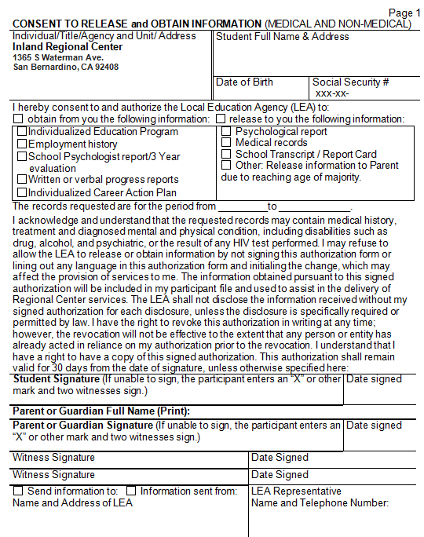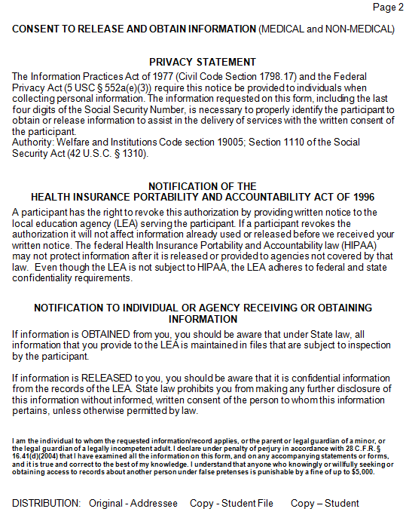
Documentation for youth and adults as it relates to CIE
The LPA core partners shall identify job readiness skills for individuals with ID/DD that lead to competitive integrative employment outcomes.
The LPA core partners shall collaborate to prepare individuals within the ID/DD population to promote and develop their level of pre-vocational skills. Efforts specific to each agency:
- DOR: Counseling and Guidance, Self Advocacy, Career Exploration, Work Experience, Customized Employment, Employment Services
- IRC: Paid Internship Program, CIE Incentive Payment
- LEA: Transition Planning, IEP, WorkAbility I, We Can Work Contracts, Adult Transition Program, Transition Partnership Programs
- Community Partner Agencies: Employment Preparation, Job Placement, Job Coaching, Personal Vocational Social Adjustment, External Situational Assessment, Work Experience.

Other documentation relevant to the collaboration of the local partners such as:
- Use of DOR’s Work Incentives Planning Program to educate individuals with ID/DD and community partners about the impact of employment on benefit entitlements, available work incentives provided by the Social Security Administration, wage reporting rules, and community resource information.
- The Potentially Eligible (PE) student with a disability is not required to apply for VR services before receiving DOR Student Services. The DOR serves PE Students through the PE Case Type. The purpose of offering services to PE Students is to provide early intervention to students with a disability to support their participation in activities to maximize opportunities for future employment success.
- DOR Student Services help students prepare for workplace success by exploring options, getting ready for work, and creating careers.

Exhibit H – DOR Student Services Options (succeeding page)

Resources

The following are examples of IELPC’s resources to improve CIE outcomes:
- Tailored Day Services
- Career Counseling Information and Referral
- Future community-based vocational development services (authorized by Senate Bill 577)
- Paid Internship Program (PIP) – $10,400 per client
- Customized Employment
- DOR Business Specialists
- IRC Employment Specialists
- CIE Incentive Payment
- Work Incentive Planning

Existing local agreements
- Business engagement practices to promote employment opportunities for consumers. DOR Business Specialists shall provide Windmills training to businesses. Windmills training can be customized to change attitudes concerning individuals with ID/DD to promote CIE opportunities for the said population.
- IELPC shall collaborate with San Bernardino and Riverside County WDBs to increase disability awareness, incentives and additional benefits associated with hiring individuals with ID/DD.
- IELPC shall develop a strategic plan to increase employment outcomes for individuals with ID/DD
- IELPC shall identify and develop additional opportunities with the following programs: College to Career, Project Search, and Independent Living Centers.
- Workforce Development Boards/AJCCs will provide workforce trends in the local communities to the IELPC core partners.

- Communication:
The IELPC will maintain ongoing communication amongst all core partners. Meetings will be established at mutually agreed upon intervals for the purpose of dialogue related to training opportunities, best practices and sharing resources.
- The IELPC shall use the Workforce Innovation Technical Assistance Center (WINTAC) resource for ongoing training and support.
Functional:
- IELPC will meet at mutually agreed upon intervals.
- Leadership of the LPAs will be determined by the local core partners.
- Updating the LPA will be completed in collaboration with all IELPC core partners as needed.
System Measures
- Please refer to DOR Inland Empire District strategic goals for increasing levels of CIE opportunities for individuals with ID/DD.
- DOR will utilize the Aware database to track ID/DD outcomes
- DOR will utilize Potentially Eligible tools to identify individuals who can benefit from CIE outcomes.
- LEA will complete data tracking of youth population with ID/DD who are nearing school exit.
- IRC Transition Division will complete monitoring of caseload levels related to individuals also nearing program transition/exit and share that information to the IELPC accordingly.
DOR Supported Employment Liaisons by Unit

Exhibit E -- Inland Empire District CIE SPOC information

Optional Attachments/Appendices
•Terminology
- Each IELPC core partner to provide terminology, acronyms and definitions specific to their respective program.
•LPA Cross Training
- LPA core partners will provide cross training informational sessions.
For example:
- •In the spirit of collaboration, regional centers that have adopted an Employment First policy will be encouraged to share their policy with regional centers that have not adopted an Employment First policy. As needed, technical assistance will be provided to regional centers and their boards to complete this work.

The IELPC Regional LPA Strategic Plan Goals for 2018-2019.
  - Implement a common referral form within the high schools
  - Develop common assessments related to CIE to be implemented within the high schools
  - Develop a resource guide to give parents and students at the exit IEP describing the referral processes, terminology and agency supports available to them
  - Enhance employment opportunities to the consumers we are serving (youth, regional center, and student disabilities).
  - Training
    - Training programs, life skills, transportation training, etc.
    - School staff
    - Communication and Coordination (Including SELPAs)
    - Sharing impacting changes as received by each LPA partner
    - Identify audience and develop LPA materials
  - Increase vendors by adding LEA for job coaching services (aka short-term supports) for the IRC PIP.

Action Plans with Associated Target Dates:
- CIE Blueprint Strategic Plan and Goals – (Refer to the Exhibit F -DOR Inland Empire District CIE Blueprint Strategic Plan 2018-2020) - Target Date: December 2020
- IELPC core partners shall establish approximately 4-7 LPAs specific to the CIE goals of their catchment area. - Target Date: June 2020
- IELPC core partners will continue to collaborate on the best practices, communication, cross-training, resource building, networking and others efforts leading to the promotion of CIE outcomes for youths with disabilities. Target Date: Ongoing
- IELPC core partners shall continue to meet and engage in cross-training opportunities. (Refer to the Exhibit G - IRC & DOR Cross-training) - Target Date: Ongoing
- In the spirit of early intervention, IELPC core partners shall identify opportunities for outreach to PE SWDs in Workability I, so that they can receive DOR Student Services leading to CIE outcomes. Target Date: Ongoing
- Establishment and implementation of a standardized referral form which can be utilized by all core partners. Target Date: Ongoing
- Identification of community resource providers which provide job coaching services. Once identified, provide job coaching staff with cross-training opportunities. Target Date: Ongoing
- Implementation of same-day eligibility determination for individuals with ID/DD who are seeking CIE opportunities. Target Date: Ongoing

DOR Inland Empire District Core Partners

________________________________
Robert Loeun, DA

________________________________
Alfonso Jimenez, TM

________________________________
Paul Ceballos, DOS TM

________________________________
Joyce Holzer, TM Temecula

________________________________
Chris Fernandez, TM Riverside

________________________________
Nicolas Jimenez, TM El Centro

________________________________
Mario Linares, TM Riverside

________________________________
Pauline Pina, TM Ontario
________________________________
Craig Rubenstein, TM Riverside

________________________________
Janie Delgadillo, TM Palm Desert

________________________________
Susan Wright, TM Victorville

________________________________
Thomas Darby, TM San Bernardino

___________________________
Yukiki Long, TM BFS

LEA Core Partners

_______________________________
Lynn Smith, RCOE

_______________________________
Adrienne Shepherd, D/M SELPA

_______________________________
Jennifer Braddick, W/E SELPA

_______________________________
Chris LeRoy, SBCUSD

_______________________________
Colleen Meland, East Valley SELPA

IRC Core Partners

_______________________________
Vince Toms
Comm. Services Director

_______________________________
Andrew Burdick
Employment Specialist

_______________________________
Felipe Garcia
Children's and Transition Director

______________________________
Beth Crane
Employment Specialist

