Competitive Integrated Employment Blue Print

Orange County Local Partnership Agreement

Intent/Purpose

The purpose of the Orange County Local Partnership Agreement (OCLPA) is to enhance partnerships that promote preparation for and achievement of competitive integrated employment (CIE) for youth/adults, 14 years old through 30 years+, with disabilities and related “At Risk” populations including individuals with intellectual disabilities and developmental disabilities (ID/DD).

OCLPA Partnerships

The OCLPA includes partnerships that have been operational for over 15 years as well as new partners that have been established for a variety of workforce development programming opportunities. The following OC Competitive Integrated Employment (CIE) Local Networking Chart identifies current partnerships and programming options.

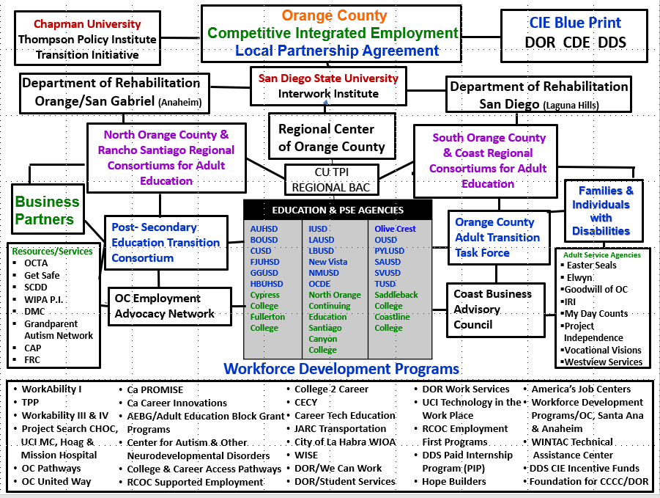

Identification of Core Partners

OC LPA Core partners are the LEAs, DOR districts, and the regional center as follows:
- Regional Center of Orange County
- Department of Rehabilitation Anaheim Office/Orange San Gabriel Valley District
- Department of Rehabilitation Laguna Hills Office/ San Diego District
- Education Agencies
- Anaheim Union High School District
- Brea Olinda Unified School District
- Capistrano Unified School District
- Fullerton Joint Union High School District
- Garden Grove Unified School District
- Huntington Beach Union High School District
- Irvine Unified School District
- Laguna Beach Unified School District
- Los Alamitos Unified School District
- Newport-Mesa Unified School District
- New Vista School
- Olive Crest Academy
- Orange County Department of Education & OC Pathways
- Orange Unified School District
- Placentia-Yorba Linda Unified School District
- Santa Ana Unified School District
- Saddleback-Valley Unified School District
- Tustin Unified School District

Identification of Community Partners
The OCLPA has many organization & stakeholders who have agreed to participate and support CIE and related programming. Please see the attached OC LPA Local Networking Chart.

This is just the beginning. New partners will be added as needs are identified to support workforce development programming and CIE.

Additional Community Partners:

Our partnerships include:

Local Education Agencies | Workforce Development Programs
Career Pathway Programs | Disability Related Resource Agencies
Post-Secondary Education & Training | Disability Advocacy Organizations
Adult Service Providers | Foundations/Private Non-Profits

San Diego State University, Interwork Institute and Chapman University Thompson Policy Institute Transition Initiative will provide leadership in data collection and research efforts.

Collaboration through Person-Centered Processes: Roles and Responsibilities

Coordinating Person-Centered Planning
- Need:
In California, according to the Department of Developmental Services the employment rate for individuals with Intellectual and Developmental Disabilities (IDD) is about 13.1%, as compared to the general population rate at 74.7% (2014). Youth and adults with IDD need skill development and work experience opportunities to ensure success in CIE. Initially, individuals with IDD need to be made aware that CIE is an option for them. Additionally, they need to want to work, and be able to express their desire to work. A Person Centered/Driven Planning Process is an essential first step in this progression.

- Definition:
Person Centered/Driven Planning (PCP/PDP) is an ongoing process used to help individuals with disabilities plan for their future. In person driven planning, groups of interested people focus on an individual and that person's vision of what they would like to do in the future. The "person-centered" team meets to identify opportunities for the student to develop personal relationships, participate in their community, increase control over their own lives, secure & retain CIE and develop the skills and abilities needed to achieve these goals. Person Centered Planning depends on the commitment of a team of individuals who care about the individual. These individuals take action to make sure that the strategies discussed in planning meetings are implemented. Additionally, Person Driven Planning emphasizes the role of the individual in the transition process.

- PDP Cross Agency Agreement:
The Orange County Local Partnership Agreement (OCLPA) Team has developed a best practice person centered/person driven planning concept to support an individual’s pathway to Competitive Integrated Employment (CIE). There are many identified mechanisms for completing this process and each service organization will decide on the specifics they will utilize. Because of the individualized nature of this planning, this process will look different for each person. To promote coordination across agencies we may utilize the same initial one-page PCP/PDP Planning Tool. Please see attachments including; 1) OCLPA PDP for Work Training and Employment & 2) OCLPA CIE PDP Process Directions:

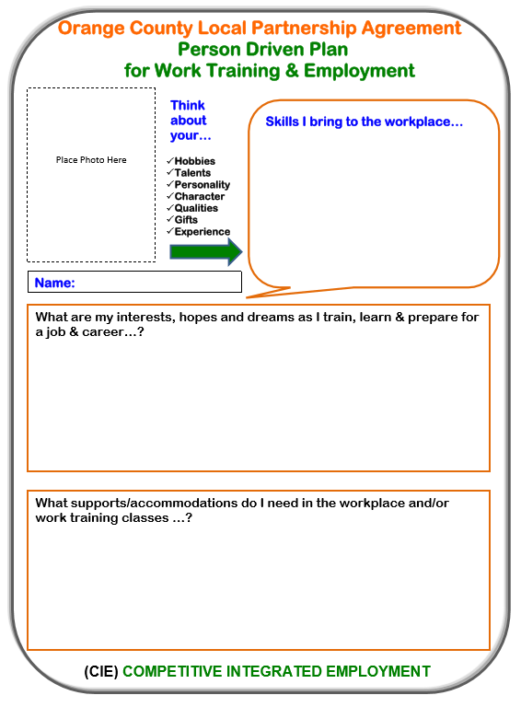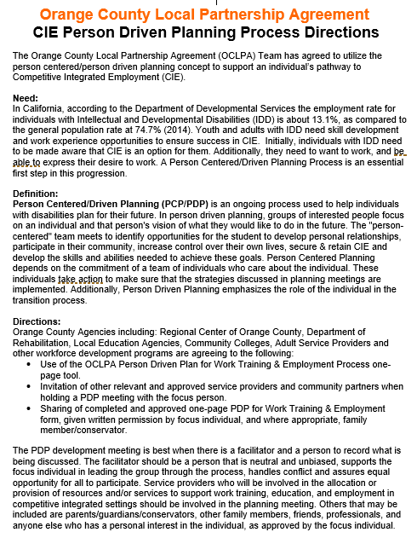

Questions that we will continue to work on:
- How will we invite applicable agencies to PDP Meetings to reduce duplication of effort and promote more effective and efficient planning?
- Where will be store the one-page tool for others to access with permission from the student/adult and conservator where needed?
- How will we promote self-determination skills specific to updating tool and providing to service providers?

- Individualized Planning & Coordination of Services Roles & Responsibilities:
Each organization will continue with their mandated individualized planning as follows:
- RCOC:
- Individual Program Plan (IPP) – This written plan is similar to an Individualized Education Program (IEP). It outlines special services, goals and objectives for a person who needs individualized help because of a developmental disability. The Regional Center and the Consumer develop the IPP.

- Individual Program Plan (IPP)-The IPP will be developed in collaboration with the consumer, the regional center Service Coordinator, and others as requested.
The Individual Program Plan (IPP) meeting is an annual meeting held with the individual served, members of his or her circle of support, and the Regional Center Service Coordinator to discuss the individual’s goals, desired outcomes, and plans. This meeting is held annually during the individual’s birth month or when needs are identified. The IPP team also discusses how community resources and Regional Center funded services help the individual meet his or her plan objectives. The Regional Center Service Coordinator completes a comprehensive IPP report that includes information from the meeting and services to address plan objects. The IPP report, which serves as a contract for services, is completed and shared within 45 days from the meeting.

- DOR:
- DOR Eligibility:

“If DOR receives complete information about your disability, your VR
counselor will notify you in writing of your eligibility within 60 days of
meeting the three requirements of application. If information about your
disability is incomplete or delayed, you and your VR counselor will agree on
a specific extension date to determine your eligibility.”

There are three requirements that comprise the application process.
1. Request VR services in one of the following ways:
a. Contact the local DOR office in your area. Complete and sign form
DR 222—Vocational Rehabilitation Services Application.
b. Apply for Services online at the DOR website: www.dor.ca.gov or
print an application from the DOR website and mail the completed
form DR 222—Vocational Rehabilitation Services Application to
your local DOR office.
c. Visit a One-Stop Center. Complete an intake application form
requesting VR services.
2. Provide DOR with information necessary to begin an assessment to determine eligibility and priority for services.
3. Be available to complete the assessment process. This includes activities such as attending the initial interview, watching an orientation video, participating in the evaluation of your skills and capabilities, and completing your part of any actions you and your VR Counselor have agreed to.

- Individualized Plan for Employment (IPE) – A term used by the California Department of Rehabilitation to refer to the contract between the client and the CDOR. The IPE contains important information on the client’s employment goal, and what services and supports the CDOR has agreed provide to assist the client in meeting that goal.

- Individualized Plan for Employment (IPE)
- The IPE will be developed in collaboration with the consumer, the Department of Rehabilitation (DOR) Counselor, and other stake holders to assist in development of the employment goal when the following are met:
- Have applied for services.
- Completed the assessment process.
- Are found eligible for services.
- Are placed in a disability priority category being served.
The IPE is a written plan listing consumer job objective and DOR services the individual will receive to reach his/her employment goal. The consumer and DOR counselor will discuss the individual’s unique strengths, resources, priorities, concerns, abilities, capabilities, interests, and informed choice. The IPE should be developed prior to consumer transitioning from Secondary Education, Alternative Schools, or Post-Secondary Education. The IPE will be developed within 90 days of eligibility determination.

- Local Education Agencies & Additional Education Agencies:

- Individualized Education Program (IEP) – Required by IDEA, and used in K12 educational agencies for individual student planning. The IEP is developed by a team of people such as parents, teachers and psychologists. The IEP describes the direction a student with special needs will be going in the future and how to get there.

- Individualized Education Program (IEP)
The IEP will be developed in collaboration with the IEP team, the parents, teacher, student, and others as requested.

- When a purpose of the IEP meeting is the consideration of transition services for a student, the LEA shall invite the student and, to the extent appropriate and with the consent of the parent or adult student, a representative of any other agency that is likely to be responsible for providing or paying for the transition services.

- Individual Transition Plan (ITP) –The ITP is the template for mapping out long-term adult outcomes from which annual goals and objectives are defined. The ITP must be based on the student’s needs, preferences and interests and reflect the student’s own goals. Objectives, timeliness, and people responsible for meeting the objectives should be written into the ITP (and made part of the IEP). It is important to understand that transition planning and development of the ITP are part of the IEP process. The ITP must be in place by the time the student turns 16 years of age. If the IEP Team Agrees transition planning can begin prior to the age of 16.

- California’s Career Technical Education/Preparing Students for the 21st Century
- A student’s ITP Plan would include a K-14 to Workforce Pathway. Students will be encouraged to take courses in high school within one of the 15 Industry Sectors. Examples include:
- Arts Media & Entertainment
- Hospitality, Tourism & Recreation
- Marketing, Sales & Services
- Health Science & Medical Technology

- As students transition to their PSE experience they will be encouraged to continue taking courses in a “Guided Career Pathway” at a community college.

Students completing 2 courses in the same Career Tech Ed/Career Pathway who also earn an industry recognized certificate or acquire WBL competencies would achieve “Prepared” status through the College/Career Indicator Performance Levels. This measures post-secondary preparedness identified as part of the California School Accountability Dash Board.

- Community Colleges:
- Academic Accommodation Plan (AAP) – SECTION 56022. ACADEMIC ACCOMMODATION PLAN (AAP).
- Each college shall generate an Academic Accommodation Plan (AAP) and maintain a record of the interactive process between each DSPS student and a DSPS certificated staff member regarding the academic adjustments, auxiliary aids, services and/or instruction necessary to provide the student equal access to the educational process, given the educational limitations resulting from the student's disabilities. In addition, when a student is enrolled in educational assistance classes the AAP shall define measurable progress toward the goals of each class. (5 C.C.R., § 56022)

- From the implementation guidelines:
California Community Colleges Chancellor’s Office. (2015). DSPS Implementing Guidelines for Title 5 Regulations. Retrieved on September 25, 2017 from http://extranet.cccco.edu/Divisions/StudentServices/DSPS/StatutesRegulations.aspx

- As per the original intent of the Americans with Disabilities Act (ADA) and the subsequent 2008 amendments to the ADA, and as described in the Association on Higher Education And Disability (AHEAD) document “Supporting Accommodation Requests: Guidance on Documentation Practices, 2012”, there must be an individual “deliberative and collaborative process” on the part of the college with each student requesting academic adjustments, auxiliary aids services and/or instruction for their disabilities and the resulting educational limitations.

- The “deliberative and collaborative process” may be documented through standardized forms as described below in the “Documentation” section, and/or through narrative notes describing the interaction(s) between certificated DSPS staff and the student.

- The Academic Accommodation Plan (AAP) may take different forms and have different titles at each college. The important factor is that there is a record of the academic adjustments, auxiliary aids services and/or instruction approved for each student. There may be a single accommodation plan generated when the student first applies for DSPS services, which is then referred to while determining
appropriate academic adjustments, auxiliary aids and services per class, per academic term. Or there may be multiple accommodation plans, which list the academic adjustments, auxiliary aids services and/or instruction determined and documented for each class in each academic term. Regardless of the format, the requirement is that there must be a record of the interactive process and the academic adjustments, auxiliary aids services and/or instruction that have been approved for the student for each class.

- Additionally, by 2019 Irvine Valley College Santa Ana College will pilot the Guided Pathways Framework which will create a highly structured approach to student success that provides all students with a set of clear course-taking patterns that promotes better enrollment decisions and prepares students for future success. The Guided Pathways framework also integrates support services in ways that make it easier for students to get the help they need during every step of their community college experience.

The Guided Pathways Model creates a highly structured approach to student success that:
    - Provides all students with a set of clear course-taking patterns that promotes better enrollment decisions and prepares students for future success.
    - Integrates support services in ways that make it easier for students to get the help they need during every step of their community college experience.
Key Elements:
- Structured onboarding processes
- Programs that are fully mapped out and aligned
- Proactive academic and career advising
- Responsive student tracking systems
- Redesigning and integrating basic skills/developmental education classes
- Instructional support and co-curricular activities

As this pilot program identifies effective and best practices, they will be expanded to Orange County’s other 8 community colleges.

- American Job Center of California/OC One Stop System:
- VISION: The local strategic vision is to fuel collaborative partnerships, system alignment, policy development, funding oversight, and an integrated and innovative service delivery system that drives workforce and economic development to support and strengthen growth for the local and regional economy and economic self-sufficiency for individuals.

- GOALS: Based on analytical background information presented in the OC Regional Plan, the OC Unified Local Plan’s vision and corresponding goals are designed around articulating service delivery at the local level that aligns with the regional labor market needs and system architecture blueprint laid out in the regional plan.

- Individual Service Strategy (ISS) –
An individual service strategy (ISS) is an individual plan for a youth which includes an employment goal, appropriate achievement objectives and the appropriate combination of services for the participant based on the objective assessment. The ISS is used as the basic instrument for the local area to document appropriateness of decisions made about the mix and combination of services, including referrals to other programs for specified activities. It needs to be completed at the time of enrollment. The recommended timeline for updating the ISS is every three months.

The WIOA enhances the youth program design through an increased emphasis on individual participant needs by adding new components and incorporating career pathways to the objective assessment and individual service strategy.

Document sharing will be facilitated where appropriate and with the approved “Release of Information Documents”.

Referral and Intake

The OCLPA Referral Process has been identified by DOR, RCOC and LEA’s as laid out in the following Orange County Work-Based Learning Tools (OCWBL #3 & #6). This on-going process has been worked on over the last 5 years and includes input from adult service providers, family members and individuals with disabilities. It is creating coordinated and well-sequenced service delivery for individuals with disabilities.

OCWBL #3: Regional Center/DOR/Adult Program Employment Rating Referral Summary Chart
This form is intended to provide summary information to agencies that will be providing employment related services to our participants before and after graduation. This includes summarizing employment related information to be provided to:
- Department of Rehabilitation
- Regional Center
- Adult Service Provider Agencies

The 1-5 scale listed in the Score Description box is used to rate the employment skills development of the individual. This is the same point scale as used in form OCWBL#2. The total point values are different because only the major categories are scored, not the individual skills as in form OCWBL#2. The total points specific to the different programming recommendations are as follows:

#1 Competitive Integrated Employment (CIE) Individual Placement (34-40)
#2 Supported Employment Individual Placement in Integrated Setting (30-35)
#3 Supported Employment Group in Integrated Setting (26-31)
#4 Adult Day Services/Employment & Volunteer Work Individual/Group Integrated Setting (22-27)
#5 Adult Day Services/Work Training &/or Volunteer Work Group Integrated Setting (23 & Below)

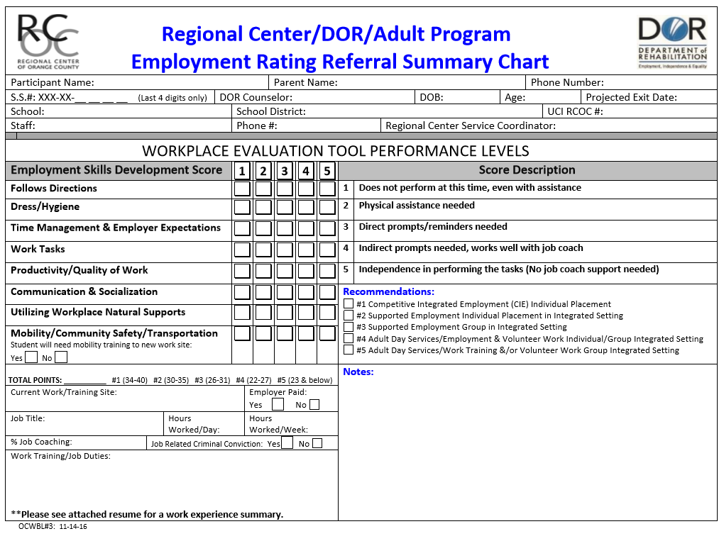

OCWBL #6: Orange County Regional Center & Department of Rehabilitation,
Transition to Adult Work Training & Competitive Integrate Employment Services Timeline
This chart below was developed to provide an approximate time line for DOR, RCOC, school district staff, consumers/students and family members in facilitating a smooth move from school to the adult service provider system. It lays out the action timeline that should be used to promote identification of appropriate adult programming for students/Regional Center of Orange County (RCOC) Consumers/Department of Rehabilitation (DOR) Consumers leaving Local Education Agencies (LEA) with a Certificate of Completion or Diploma. All students should be encouraged to complete transition activities related to education, employment and independent living identified on their Individualized Transition Plan (ITP) prior to exit from their school district up to and including the age of 22. Competitive Integrated Employment (CIE) is encouraged prior to & after school exit. The exit date is determined by the LEA using date of birth.

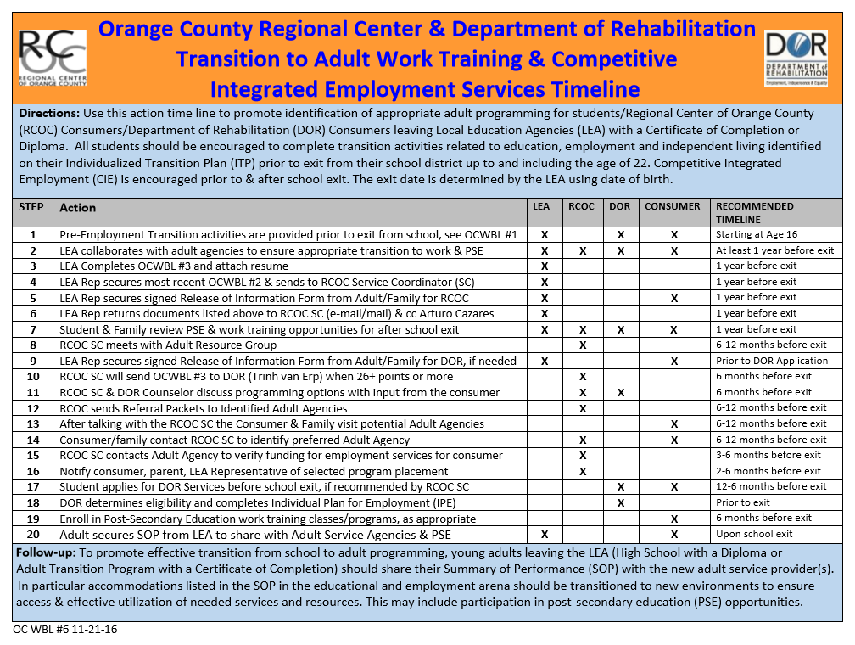

As we continue to expand partnerships through the OC LPA we will determine additional practices that will be added to the timeline to support an individual’s CIE goal. We will continue to review and revise these tools as more efficient procedures are identified. Additional, efforts will be made to revise the OC Work-Based Learning Tools to include methods to address individuals with a wide range of disabilities.

Information Sharing and Documentation Processes

Existing Eligibility & Planning Documentation:

Several methods to promote cross agency sharing of eligibility & planning processes & documents are currently utilized:

The Identified CIE Service Timeline (OCWBL #6)

OC Regional Center & Department of Rehabilitation Transition to Adult Work Training & Competitive Integrated Employment Services Timeline (OCWBL #3)

Summary of Performance (SOP) availability and sharing across agencies

An exchange guideline will be developed to promote sharing of relevant data.

New and Improved Information Sharing Processes:

Several new methods for information sharing are being developed in response to the Pre-Employment Transition Services programming for students with disabilities specific to WIOA requirements. This includes Career Counseling & Information and Referral (CC&I&R) to promote CIE vs subminimum wages.

An SOP exchange guideline will be developed to promote sharing of employment and PSE/Training information from schools to relevant adult service provider agencies and educational institutions.

Multi-agency sharing of employment and PSE/Training information with individual with disabilities informed permission.

Current data collection/sharing methods will be reviewed to assist with improved data collection/sharing across agencies to promote positive outcome sharing and identification of best/effective CIE practices and procedures.

Process to Address Individuals for Whom Documentation is Not Available:

For individuals without documentation of disability and past experience will be assisted with:

Retrieval of disability verification documents

Access to testing & evaluation services to document disability, needed services, as well as, education and employment related accommodations.

Person Centered Processes for “Consent for Release of Information”

At the current time, all agencies will utilize their own “Consent for Release of Information” to ensure legal requirements of the individual agencies. As we proceed with the OCLPA process, we will explore the possibility of a universal release of information. We will model it after the MOUs that have been created for use in

the OC Project Search Programs.

Resources & Tools:

Through the OC LPA partnerships, available resources have been identified as seen in the OCWBL #8 chart below. Additionally, new resources and services are being developed, and expanded based on new partnerships being established.

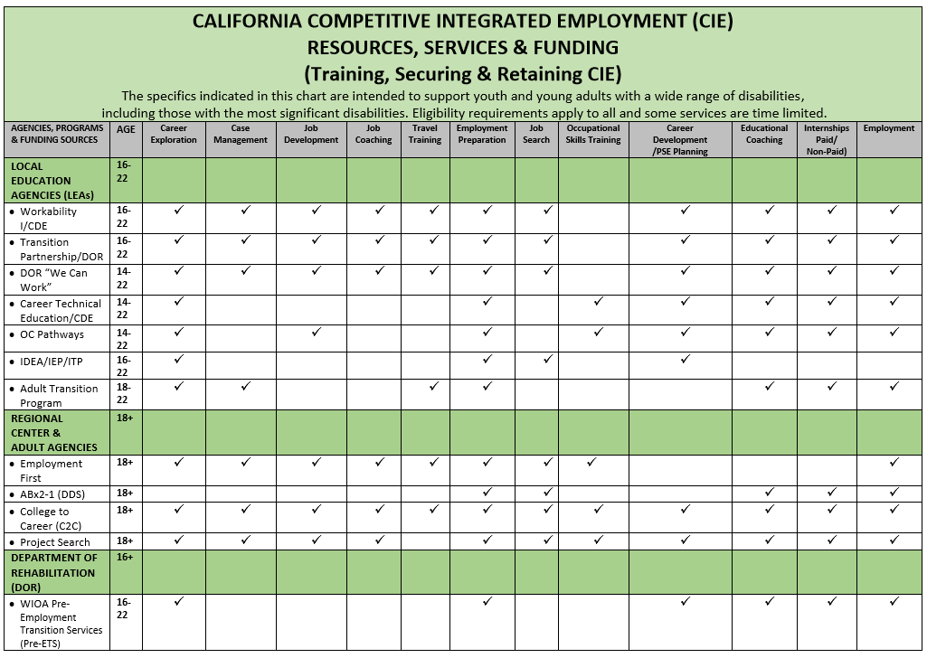

Chapman University’s Thompson Policy Institute, Transition Initiative Website

Through a collaboration with the Chapman University’s Thompson Policy Institute (TPI), Transition Initiative, resources and services identified through the multitude of OCLPA partnerships will be placed on a new website. This website is currently under construction and will include transition related information for a variety of stakeholders including: individuals with disabilities, families, educators, adult service providers, agencies, advocacy groups, medical professionals, university researchers and others. Specific aspects of the website will be completed to ensure easy access and use ability for all stakeholders. The TPI will oversee the ongoing maintenance and updates that will be needed.

Additional documents verify OCLPA Partnerships Including:

Chapman University Thompson Policy Institute (TPI), Transition Initiative

The TPI Transition Initiative strives to improve transition outcomes (e.g. employment, housing, social emotional) for people with disabilities; supporting these individuals in leading happy, healthy, and meaningful lives. We will accomplish these goals by creating a network of transition organizations and programs that effectively communicate, collaborate, and share data to enhance services and ultimately outcomes for people with disabilities both locally and nationwide. The TPI Transition Initiative is made up of a leadership group, as well as sub-committees that are tasked with addressing specific areas of transition. We currently have two active sub-committees designed to address employment gaps and needs (business advisory committee) and improve the knowledge base of transition intervention in our community (education and training committee). The OCLPA has become its newest work team. Please see the TPI Work Team Chart.

Orange County Work-based Learning System Tools
- OCWBL #1: Orange County Pre-Employment Skills Development Chart Preparing Youth & Adults with Moderate to Severe Disabilities
Preparing youth and adults for CIE and careers, starts well before age 16. As individuals with disabilities, families, school staff and community agencies focus on transition planning, employment and career development, there is an expectation that employment options will be available. It is our responsibility in the schools, in the community and at home to promote and support the acquisition of skills that will prepare our youth/adults to secure and retain jobs that are competitive and integrated. This chart identifies the skills specific to the environments where individuals learn the skills needed for success in the workplace.

The chart is divided into (4) columns including the following domains: Workplace, School, Community and Home. The skills listed under the Workplace column have been verified by business representatives as skills needed for successful employment. The School, Community & Home Columns include activities that will promote employment related skill development. Families, school staff and community members all have an important role in helping youth/adults learn expected behaviors. As you work with your youth/adults, please be mindful that the identified skills listed under the School, Community and Home domains will support the development of employability skills. The Community Domain applies to skill development supported by all service providers, educators and family members. Collect baseline data on the form and then rate the individual on a monthly/quarterly basis. Tracking progress will help to identify training needs and will assist in better preparing youth for positive work experiences with the goal of participating in paid employment and eventually obtaining economic self-sufficiency.

- OCWBL #2: Orange County Employment Skills Development Chart
This form is used for on-campus or community-based work training evaluation.
The employment skills listed on this form are separated into major categories
including:
- Follows Directions
- Dress/Hygiene
- Time Management & Employer Expectations
- Work Tasks (specific to work training duties/job descriptions)
- Productivity/Quality of Work
- Communication & Socialization with Supervisor and Co-workers
- Utilizing Workplace Natural Supports and/or Job Coaching
- Mobility/Community Safety/Transportation Options

  - OCWBL #2b: Orange County Employment Skills Development Chart with Directions
This chart is the same chart as OCWBL #2 above, it explains scoring methods. The directions listed in green print below some of the skills, are intended to promote consistency and accuracy in point assignments.

- OCWBL #3: Regional Center/DOR/Adult Program Employment Rating Referral Summary Chart
(Described above)

- OC WBL #4: Employment / Work Training Readiness Scale
(Described above)

- OCWBL #5: Orange County Employment / Work Training Terms & Legislation
This document contains definitions of transition and employment related terminology.

OCWBL #6: Orange County Regional Center & Department of Rehabilitation, Transition to Adult Work Training & Competitive Integrate Employment Services Timeline
(Described above)

- OCWBL #7: RCOC Adult Day Services Model Chart
This chart is intended to describe Adult Service Programs available through the Regional Center of Orange County.

- OCWBL #8: California Competitive Integrated Employment (CIE) Resources, Services & Funding Chart (Training, Securing & Retaining CIE)

The specifics indicated in this chart are intended to support youth and young adults with a wide range of disabilities, including those with the most significant disabilities. Eligibility requirements apply to all and some services are time limited.
- OCWBL #9: Orange County Work-Based Learning, Employment & Career Development System WBL Handbook
This handbook provides detailed information regarding each of the Work Based Learning Tools.

- OCLPA Partnership Teams & OC Workforce Development Programs
This document outlines the collaborative groups that members of the OCLPA Steering Committee participate in or oversee. At this time, these groups number 24. Additionally, a list of 16 workforce development programs represented by the membership. Please see OCLPA OC Collaborative Teams document.
We are in the process of putting together programming information specific to these lists on the Chapman University Thompson Policy Institute Transition Initiative Website which will support easy access of transition and CIE information to all of our stakeholders.

Project Search Memorandums of Understanding:

Adult Education Block Grant (AEBG) Work Plans

Relevant documents will be included as attachments to this narrative.

Additional, collaborative practices will include efforts to reduce duplication efforts

Through the various collaborative groups, with leadership provided by the OCLPA, we

will work to optimize the use of local partner resources and services. This effort will promote CIE and improve career options through transition planning, and post-secondary education/training leading to positive life outcomes for people with disabilities.

Communication

Informational

Local Efforts:

Developed materials, programming documents and success stories will be shared with stakeholders including families and individuals with disabilities using the following methods:

Chapman University Thompson Policy Institute

Website (We have received a donation to develop this website.)

Transition Related Blogs

Workshops

Regional Center of Orange County Website

Transition Programming

Workshops

Twitter

Adult Education Block Grant (AEBG) Consortium/Community College/LEA Programming

Several meetings are held for planning and development purposes, including:

Executive Meetings

Public Input Meetings

Disability Services Work Group Meetings

Community wide efforts are under way to develop and implement new and enhanced employment development programming.

Social Media efforts are being explored to support our communication efforts.

State Level Communication:

Frequent communication is kept with CIE Leadership Team Members through a variety of California State Advisory Committees including:

CIE Blue Print Committee

CaPROMISE Interagency Council Meeting DOR State Office

CECY (California Employment Consortium for Youth) UCLA

Technical assistance is requested and received on an on-going basis.

Functional

Local Communication Process:

OCLPA Steering Committee, including core partners, is currently meeting face to face once per month for one hour and 30 minutes. As we proceed we may decide to add conference calls using ADOBE for some of the work team efforts. Additionally, emails and phone calls are assisting with document and process development

Currently, the core partners meet in person and by phone to set the face to face monthly meeting agendas. Additional Meetings that facilitate LPA Partnership Efforts include:
- Chapman University Thompson Policy Institute Orange County Transition Initiative
- Orange County Work Services Committee/DOR
- Employment Community Advisory Committee/RCOC
As we work to bring on new membership/partners, the following key staff members are providing leadership:
- Janis White, Chief Operating Officer, RCOC
- Arturo Cazares, Employment & Day Services Manager
- Trinh van Erp, Staff Services Manager, DOR, Anaheim Office
- Kurt Kosbab, Vocational Specialist, Huntington Beach UHSD

- Linda ONeal, Chapman University, Thompson Policy Institute & RCOC
- Adam Gottdank, Director Disability Support Services, North Orange County Community College District Continuing Education
- Karen Gibbs, Administrator, Irvine USD

Leadership efforts include: presentations, discussions, Q& A Sessions, email contacts, and phone calls. Efforts are made to ensure administrators from the various organizations are kept up to date and LPA efforts to ensure buy-in and organizational support.

Updating the LPA documents and tools is on an on-going process. Revised materials are emailed to LPA membership prior to calls and meetings for input and prior preparation for discussions.

Cross Agency Programming

The OCLPA will serve as the functional collaborative that will promote cross agency service delivery efforts. Specifics will include:

Addressing systems issues

Problem solving for CIE programming

Grant writing/letters of support

Affecting legislative & policy efforts (Chapman University Thompson Policy Institute & San Diego State University, Interwork Institute)

Initial efforts to promote cross agency collaboration will focus on the DDS/ Regional Center Programs’:

Paid Internship Program

CIE Incentive Program

System Measures
The OC LPA will be collecting, monitoring, and reporting transition, CIE and PSE Data. The research processes will be supported by:
- Department of Developmental Services
- Data Dash Board
- Regional Center of OC
- CIE Data Collection
- San Diego State University, Interwork Institute Federal Grants:
- California Promise Initiative
- California Career Innovations
- California Department of Education
- WorkAbility I
- Department of Rehabilitation
- Transition Partnership Program
The Chapman University Thompson Policy Institute has identified a Research Team to pull together data from these multiple sources. The OCLPA will be setting outcome measures and using the data to improve programming efforts.

Contact Information
The OCLPA Steering Committee Membership including: DOR, RCOC and LEA and other essential partners is included as an attachment. We are continuing to develop the membership in the OCLPA North and South Team. Please see the attached OCLPA Steering Committee List.

Optional Attachments/Appendices
- Collaboration documents for Section III will be included.
- An OCLPA CIE Blue Print Glossary has been developed to assist staff across all agencies with familiarity of terms and acronyms used specific to CIE, PSE and Transition Planning.
- Regional Center of Orange County Employment First Policy
- OCATTF Membership List (To be sent at a later date.)
- OCDE Program/Resource Directory
- Post-Secondary Education Consortium Membership List (To be sent at a later date.)
- OCLPA Person Centered/Driven Planning Documents
- OCLPA Steering Committee
- OCEAN Membership List
- OCLPA Networking Chart
- Coastal BAC Membership List (To be sent at a later date.)
- OCLPA Collaboratives & Workforce Development Programs
- Chapman University, Thompson Policy Institute Transition Initiative Work Teams

3-19-18

