How to Navigate the SHIPM Document in Adobe Acrobat or the free Adobe Reader.

Please download the SHIPM Document and use either Adobe Acrobat XI or higher or the free Adobe Reader.
To make navigation within the SHIPM document easier a table of contents is included that can be clicked and it will take you directly to the desired Policy.
To return to the table of contents you will need to click 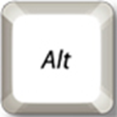 + and you will be returned to the table of contents.
Also within the SHIPM document are terms that linked to the definitions at the back of the document. To return to the policy you had clicked from you will need to click + and you will be returned to previous location.
To return to a previously clicked location use the + .

