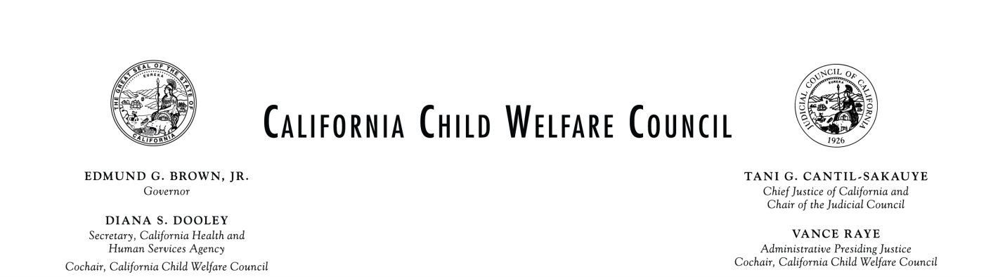
Meeting Agenda
Wednesday March 6, 2013
9:30 a.m. – 12:30 p.m.

Administrative Office of the Courts
455 Golden Gate Avenue, Third Floor
San Francisco, California 94102

Please see attachment for conference call information
Time | Item | Presenters
9:30 | - Call to order  - Introductions and announcements  - Context setting and current priorities of the Council | Co-Chairs  Justice Vance Raye  Secretary Diana Dooley
9:40 | - Action Item: Approval of December 12, 2012 Discussion Highlights | Justice Raye
9:45 | - Child Welfare System Overview/Prioritization Task Force update | Lori Clarke  Don Pickens
10:00 | - Child Development and Successful Youth Transitions Committee/Partial Credit Subcommittee Presentation | Gordon Jackson  Foster Youth  Cherie Schroeder  David Ambroz  Ken Berrick
10:20 | - Informational Briefing: Child Welfare Financing Reform | Dr. Kathryn Icenhower  Will Lightbourne  Christine Calpin  Joan Smith  Joo Yeun Chang  Greg Rose
11:25 | - Commercially Sexually Exploited Children Task Force Presentation of Final Report | Gordon Jackson  Judge Stacy Boulware Eurie  Kate Walker  Sylvia Pizzini
12:05 | - Committee and Task Force Updates  - Early Intervention/Prevention Committee  - Permanency Committee  - Child Development and Successful Youth Transitions Committee  - Data Linkage and Information Sharing Committee  - Out-of-County Mental Health Services Task Force  - Blue Ribbon Commission/Child Welfare Council Joint Membership | Dr. Kathryn Icenhower  Bob Friend  Gordon Jackson  Dr. Barbara Needell  Dina Kokkos-Gonzalez  Justice Vance Raye
12:20 | - Public Comment and Closing | Members of the Public
12:30 | - Full Council Adjourns | Secretary Diana Dooley Justice Vance Raye
12:30 | - Lunch and Networking  (Council members who also serve on the Blue Ribbon Commission will gather briefly to set a date for a conference call) | All
1:00 | - Committee Meetings | All
4:00 | - Committees Adjourn | All

The order in which agenda items are considered may be subject to change. Public comment is taken prior to a vote on any agenda item as well as at the end of the meeting. If you wish to speak, place your name on the sign-in list. Prior to making your comments, please state your name for the record and identify any group or organization you represent. Depending on the number of individuals wishing to address the council, the Co-Chairs may establish specific time limits on presentations.

If presenters intend to provide exhibits or handouts to the council members, copies must be provided to Sylvia Pizzini, whose contact information is listed below, at least ten days prior to the council meeting for distribution to the council members and to the public in attendance at the meeting. Materials available for this meeting are posted on our Web site at: www.chhs.ca.gov no later than ten days preceding the meeting. Any person who wishes to request this notice or other meeting materials in an alternative format, requires translation services, or needs any disability-related modification or accommodation, including auxiliary aids or services, which would enable that person to participate at the meeting must make that request at least seven days prior to the meeting date to:
Sylvia Pizzini or Christine Cleary
Child Welfare Council
1600 9th St., Room 460, Sacramento, CA 95814
spizzini@chhs.ca.gov or christine.cleary@jud.ca.gov
Attachment

PUBLIC NOTICE AND REMOTE ACCESS TO COUNCIL AND COMMITTEE MEETINGS

California Child Welfare Council
Public notice shall be given for the date, time, location and conference call number of all Council meetings and the meetings must be accessible to the public. If a Council member joins the meeting via conference call, public notice must be given for the location from which the Council member is calling, and the location must be accessible to the public. No public notice or disclosure of location is required for non-Council members to join the meeting via conference call.

Child Welfare Council Committees and Workgroups
Members of Council Committees and Workgroups meet after Council meetings and may meet in between meetings for the purpose of carrying out approved Council work plans. Meetings and conference calls are convened by the respective chairs of these groups and do not need to be noticed publically if membership on the group is less than a quorum of the full Council. If membership on the group constitutes a quorum of the full Council or more, then public notice must be given for the date, time location and conference call number of the meeting and the meeting must be accessible to the public.

Teleconference Sites and Call-in numbers: 9:30 Am to 12:30 PM
Call-in # 1 (866) 629-7499 Passcode: 8479522#

The Council offers the option of calling in from conference call lines set up in the San Francisco and Burbank Offices of the Administrative Office of the Courts (AOC) and at another site where Council Members will be participating. Individuals may call in from their own telephones, per the above policy. These locations are:

Administrative Office of the Courts  Sacramento Office  2860 Gateway Oaks Drive, Suite 400  Truckee Room  Sacramento, CA 95833 | Administrative Office of the Courts  Southern Regional Office  2255 North Ontario Street, Suite 200  Westside Story Room  Burbank, CA 91504
TELECONFERENCE CALL IN NUMBERS: 1:00 PM TO 4:00 PM

Data Linkage and Information Sharing Committee
Call-in #: 1-866-231-3596
Enter Passcode: 7282345#

Early Intervention/Prevention Committee
Call-in #: 1 (800) 999-1683
Enter Passcode: 7111152#

Permanency Committee
Call-in #: 866-223-4039
No passcode required for this line

Child Development and Successful Youth Transitions Committee
Call-in #: 1 (866) 629-7499
Enter Passcode: 8479522#

