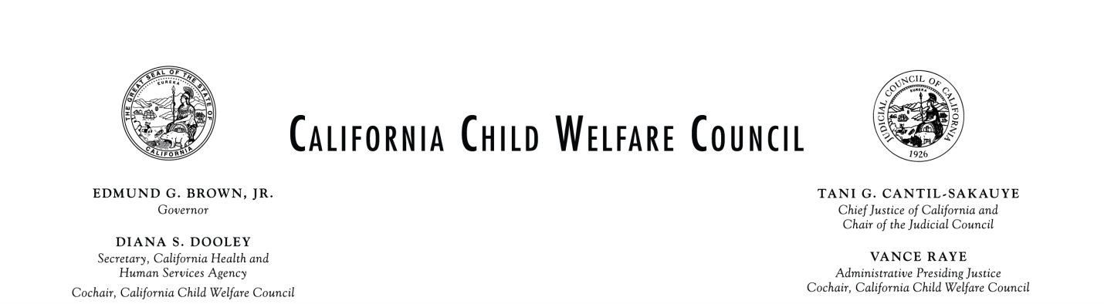
Meeting Agenda
Wednesday March 12, 2014
9:30 a.m. – 12:30 p.m.

Los Angeles County Department of Children and Family Services
425 Shatto Place, Los Angeles, California 90020

Please see attachment for conference call information
Time | Item | Presenters
9:30 | - Call to order  - Introductions and announcements  - Context setting and current priorities of the Council | Co-Chairs  Justice Vance Raye  Secretary Diana Dooley
9:40 | Action Item: Approval of December 11, 2013 Discussion Highlights | Justice Vance Raye
9:45 | Permanency Committee: Informational presentation on “The Kinship Care Paradox” | Carroll Schroeder  Bob Friend  Angie Swartz  Brian Blalock
10:45 | Action Item: Prevention and Early Intervention Committee presentation of proposed Federal Child Welfare Finance Reform Fact Sheets | Dr. Kathy Icenhower
11:05 | Permanency Committee: Informational presentation by Los Angeles Gay & Lesbian Center, Permanency Innovations Initiative RISE Project | Carroll Schroeder  Bob Friend  Dr. Curtis Shepard
11:45 | Prioritization Task Force: Informational report on the Priority Access to Services and Supports (PASS) Convening held January 30, 2014 | Frank Mecca  Dana Blackwell
12:00 | Child Development and Successful Youth Transitions Committee: Status report on implementation of the Partial Credits Model Policy | Gordon Jackson  Rochelle Trochtenberg  Ken Berrick
12:15 | - Committee and Task Force Updates  - Prevention/Early Intervention Committee  - Permanency Committee  - Child Development and Successful Youth Transitions Committee  - Data Linkage and Information Sharing Committee  - Prioritization Task Force  - Out-of-County Mental Health Services Task Force  - Blue Ribbon Commission/Child Welfare Council Joint Membership Task Force  - Ending Commercial Sexual Exploitation of Children Action Team | Dr. Kathryn Icenhower  Bob Friend and Carroll Schroeder  Rochelle Trochtenberg  Dr. Barbara Needell and  Sarah Tyson  Dana Blackwell and Frank Mecca  Dina Kokkos-Gonzalez  Justice Vance Raye  Secretary Diana Dooley and  Leslie Heimov
12:25 | - Public Comment and Closing | Members of the Public
12:30 | - Full Council Adjourns | Justice Vance Raye and  Secretary Diana Dooley
12:30 | - Lunch and Networking | All
1:00 | - Committee Meetings | All
4:00 | - Committees Adjourn | All

The order in which agenda items are considered may be subject to change. Public comment is taken prior to a vote on any agenda item as well as at the end of the meeting. If you wish to speak, place your name on the sign-in list. Prior to making your comments, please state your name for the record and identify any group or organization you represent. Depending on the number of individuals wishing to address the council, the Co-Chairs may establish specific time limits on presentations.

If presenters intend to provide exhibits or handouts to the council members, copies must be provided to Sylvia Pizzini, whose contact information is listed below, at least ten days prior to the council meeting for distribution to the council members and to the public in attendance at the meeting. Materials available for this meeting are posted on our Web site at: www.chhs.ca.gov no later than ten days preceding the meeting. Any person who wishes to request this notice or other meeting materials in an alternative format, requires translation services, or needs any disability-related modification or accommodation, including auxiliary aids or services, which would enable that person to participate at the meeting must make that request at least seven days prior to the meeting date to:
Sylvia Pizzini or Christine Cleary
Child Welfare Council
1600 9th St., Room 460, Sacramento, CA 95814
spizzini@chhs.ca.gov or christine.cleary@jud.ca.gov
Attachment

PUBLIC NOTICE AND REMOTE ACCESS TO COUNCIL AND COMMITTEE MEETINGS

California Child Welfare Council
Public notice shall be given for the date, time, location and conference call number of all Council meetings and the meetings must be accessible to the public. If a Council member joins the meeting via conference call, public notice must be given for the location from which the Council member is calling, and the location must be accessible to the public. No public notice or disclosure of location is required for non-Council members to join the meeting via conference call.

Child Welfare Council Committees and Workgroups
Members of Council Committees and Workgroups meet after Council meetings and may meet in between meetings for the purpose of carrying out approved Council work plans. Meetings and conference calls are convened by the respective chairs of these groups and do not need to be noticed publically if membership on the group is less than a quorum of the full Council. If membership on the group constitutes a quorum of the full Council or more, then public notice must be given for the date, time location and conference call number of the meeting and the meeting must be accessible to the public.

Call-in number: Full Council meeting from 9:30 Am to 12:30 PM
Call in #: 1 (866) 629-7499
Enter Passcode: 8479522#

CALL IN NUMBERS: Committee meetings from 1:00 PM to 4:00 PM

Data Linkage and Information Sharing Committee
Call in #: 1 (800) 999-1683
Enter Passcode: 7111152#

Early Intervention/Prevention Committee
Call in #: 1 (800) 999-1683
Enter Passcode: 8334584#

Permanency Committee
Call in #: 1 (866) 223-4039
No passcode required

Child Development and Successful Youth Transitions Committee
Call in #: 1 (866) 629-7499
Enter Passcode: 8479522#

CALL IN NUMBER: CSEC Action Team meeting from 1:00 PM to 4:00 PM
Call in #: 1 (866) 231-3596
Enter Passcode: 7282345#

