- Call to Order, Introductions and Announcements
Justice Raye and Secretary Dooley extended a personal welcome to members and others in attendance.

Justice Raye welcomed a new Council member, Karen Baylor, Deputy Director for Mental Health and Substance Use Disorders, Department of Health Care Services. Secretary Dooley added her words of welcome for Karen who is a key member of the Health and Human Services Agency team.

Justice Raye also announced that this would be the last meeting for Council member Kim Suderman who has ably represented the County Mental Health Directors Association over the last three years, and he wished Kim well in her retirement. The County Mental Health Directors Association has selected Dr. Terry Rooney, Colusa County to replace Kim, and Terry will be welcomed as a new member at the December meeting of the Council.

Secretary Dooley called for Introductions of all Council members and others in attendance, and then Justice Raye set the context for the meeting, remarking that the Council was setting the record for the most action items ever on a Council agenda – FIVE – including the Minutes; Annual Report; Permanency Committee recommendations; Partial Credit recommendations; and Co-Sponsorship of the “Keeping Kids in School and Out of Court Summit. He reminded Council members that as provided for in the Council’s Operation Manual, consensus would be the preferred decision making process, in other words would ask if all Council members agree that the recommendations are a good idea or if at least they can live with the directions for moving forward that are being proposed by each group. As a fallback, Co-Chairs, could ask for majority vote.

Justice Raye also noted that there were two informational presentations on the agenda, Young Children in Foster Care and an update on Federal Child Welfare Financial Reform.

- Approval of the June 5, 2013 Discussion Highlights (Action Item)
Justice Raye asked for comments or suggested revisions to the June 5, 2013 Child Welfare Council Discussion Highlights, and they were approved as written on a consensus vote.

- Approval of the 2012-13 Annual Report (Action Item)
Secretary Dooley directed Council members to “2012-13 Annual Report” document in their packets. The draft had distributed for review and comment to all Council members, and feedback was incorporated into the draft. Secretary Dooley commented that she thought the report was excellent, and several Council members expressed appreciation for its completeness and attention to details. The Report was approved on a consensus vote.

- Approval of the Permanency Committee Recommendations regarding Family Reunification (Action Item)
Justice Raye called on Bob Friend and Carroll Schroeder, Co-Chairs of the Permanency Committee, to present the Committee’s report and recommendations regarding Family Reunification, entitled, “Improving Safe Reunification of Foster Children with Their Birth Parents.” Carroll began by giving an overview of what “Permanency” means in the context of child welfare:
Children and youth are removed from their homes and placed into protective custody when they have suffered maltreatment and it is necessary to assure their safety. To remain in protective custody, children and youth must be adjudicated dependents of the court. Once a child is found to come under the jurisdiction of the Juvenile Court, s/he is remanded into the care, custody and control of the county director responsible for Child Welfare Services, and then a child welfare social worker must find a place for children and youth who cannot immediately return home to live. It may be with a relative; family friend or non-related, extended family member; licensed foster family; group home or independently in a transitional housing setting. A child or youth who lives with someone who is paid a “foster care rate” or a “relative caregiver (CalWORKs) rate” for that young person’s care is said to be “in foster care.” Foster care is temporary, and a child or youth usually remains in foster care only until there is assured a safe, permanent relationship with a caring adult who can assure the child’s well-being.

There are three different aspects permanency: Legal, Emotional and Habitation-al. One person, couple or family may provide all aspects of permanency for a child or youth. Often, various aspects of permanency are provided by different people. Permanency is both a process and a result – process includes involvement of the youth as a participant or leader in finding a permanent connection with at least one committed adult; result is connection with adult who provides a safe, stable and secure parenting relationship; love; unconditional commitment; and lifelong support in the context of reunification, a legal adoption, or guardianship, whenever possible.

Carroll then described the Child Welfare program component called “Family Reunification”:
Family Reunification includes a safe, stable and secure parenting relationship, love, unconditional commitment, lifelong support and a family home with the birth parent, or with the person with whom the child was living when taken into custody. Reunification is the first option when securing a permanent family for children and youth. Federal and state law require that child welfare workers make “reasonable efforts” to help parents reunify with children or youth removed from their care. Literature in the field suggests characteristics common to services and support helpful to families as they reunify:
- Meaningful engagement of parents, children/youth, and other family members in planning and implementing services
- Individualized assessment and case planning emphasizing both needs and strengths
- Provision of agreed upon individualized services and support

Carroll explained that the Permanency Committee focused on Family Reunification to reflect the belief that children should be raised by their parents whenever safely possible, and when children are removed from their parents, the state has a moral and legal obligation to do everything reasonably possible to return them safely home. Further, it is our obligation to help vulnerable parents meet challenges and overcome obstacles so they can safely care for their children. The Committee explored and recommended ways to improve reunification outcomes, lower rates of children re-entering foster care and maximize fiscal resources for effective services that create alternative families for children and youth least likely to achieve permanence.

Bob then explained that the Committee investigated current best practices and the literature on what works in safely reunifying families whose children are in foster care and then developed the following five theories of change the recommendations for action which flowed from each, as follows:
- Services designed to safely return children and youth to their parents need to be evidence-informed if families are to have the best opportunity to reunify. The Permanency Committee recommends that it:
  - Identify and engage appropriate body to convene social science researchers and public/private funding partners to discuss current research and further research needed in area of reunification services
  - Identify and engage the appropriate body to coordinate training in which social science researchers inform juvenile court stakeholders of current effective strategies and services that increase reunification
  - Investigate next steps to disseminate and promote implementation of these services in designated social service agencies in California

- Reunification and re-entry outcomes improve when representatives of the courts, child welfare and juvenile probation systems engage families in meaningful ways. The Permanency Committee recommends that it:
  - Encourage the use of family and child engagement practices by local courts and training of juvenile court stakeholders on these practices.
  - Work with the Board of Directors of CalSWEC to ensure that engagement policies and practices are integrated into the curriculum for child welfare social workers and administrators.

- Reunification services are most effective when they meet each family’s individual needs and build on their strengths. The Permanency Committee recommends that:
  - The California Department of Social Services, in collaboration with the County Welfare Directors Association of California and the Administrative Office of the Courts, review the case plan practices and policies for social workers and probation officers and create a mechanism by which juvenile court stakeholders, when preparing or ordering a case plan, ensure that the case plan is targeted to meet the individual needs of the family and is culturally responsive.

- Services and support, when provided to reunified families, increase the likelihood that children do not re-enter the foster care system. The Permanency committee recommends that it:
  - Request the California Evidence Based Clearinghouse develop a central online resource for research and best practice models of activities that have been successful increasing reunification and reducing reentry.
  - Support expanding and increasing the sustainability of collaborative courts, especially Dependency Drug Treatment Courts, by documenting the savings of these courts and the potential benefits that may accrue to virtuous reinvestment of county and realignment dollars. (For background information regarding California’s collaborative courts, see http://www.courts.ca.gov/documents/California_Story.pdf.)

- Resources to support permanency are enhanced by strategic investment and reinvestment in programs that reduce costs by achieving permanency for children and youth in foster care and shortening time to permanency for those just entering care. The Permanency Committee recommends:
- The California Department of Social Services, in collaboration with the County Welfare Directors Association, take the lead in providing technical assistance to counties in order to facilitate leveraged reinvestment of savings achieved by moving children and youth with delayed permanency into safe reunification.

Bob closed his portion of the presentation by reminding Council members that the Prioritization Task Force is also looking at ways to improve safe family reunification, and he noted that the efforts are not duplicative because the Permanency Committee is focusing on policies related to practice, whereas the Prioritization Task Force is looking at policies related to systems level improvements.

Bob then turned the presentation over to Leah Davis who commented that as a parent and as a Parent Leader, she can attest to how important these recommendations would be to make it easier for parents to get the services and help they need to regain custody of their children. In her job, she sees parents everyday who appreciate the fact that someone cares about them and gives encouragement and support to help them achieve the goals in their case plans, and then help them sustain the progress they have made after they have been reunified with their children. Leah then stated that the Council was honored to have two parents share their experiences about what it is like to be in the system and what it takes to for parents to reunify with their children. She then introduced Dave Shuster and Marcie Daniluke who are Parent Mentors in Santa Clara County.

Marcie shared her story of struggles with substance abuse and her children’s placement in foster care and her subsequent recovery thanks to the Santa Clara County “drug court.” She thanked Council member Judge Leonard Edwards for his role in establishing the court that supported her need to access many resources from multiple agencies in support of her recovery.

Dave shared his story of early addiction resulting in incarceration and removal of his children who were placed with his parents for which he was grateful. Through the Santa Clara drug court he was able to come to the realization that with the ability to access needed services, he could overcome the barriers to reunifying with his children and leading a clean and sober lifestyle. Dave welcomed the opportunity to thank Judge Edwards during the presentation by reaching out to shake hands as an expression of gratitude.

Justice Raye led a brief discussion on the report and presentations and called for a consensus vote which was readily provided.

- Approval of the Child Development and Successful Youth Transitions Committee/Partial Credits Work Group Recommendations (Action Item)
Secretary Dooley called on Gordon Jackson, Co-Chair of the Child Development and Successful Youth Transitions Committee, to introduce the topic. Gordon reminded Council members of the presentations on Partial Credits at the March and June meetings and introduced David Ambroz, the Council’s most avid advocate for a resolution of the problem. David summarized the issue by stating that even though required by law, the award and acceptance of partial credit for foster youth is inconsistent throughout the state, presenting an unnecessary burden to foster youth who then struggle to earn their credits to graduate on time due to frequent placement changes. The academic struggles of foster youth are well documented, including the recent report by the Stuart Foundation that was distributed to the Council.

David introduced Paige Fern of the Alliance for Children’s Rights who showed a video created by three foster youth – Michael, Selvin and Sarah – who told of their personal experiences in getting credit for academic progress they had made. Andrea Ball of the California School Boards Association then shared the results of a survey of school district and county superintendents. Of those responding to the survey:
- 70% had NO policy on award of partial credit.
- Of those who did have a policy:
  - The smallest credit for most was 0.5 credits
  - 70% said the minimum grade for passing was D or D-, with exceptions for students with an IEP that had other requirements.
  - 67% said the student must be attending the course, not just enrolled.
  - 89%t said the partial credit was awarded automatically, 11% said the student must request it.
  - Most said that the principal or counselor decides on who decides what partial credits to award.
  - Most said factors used in determining partial credit were grade earned and seat time, with course content being considered by some.
  - 95% said the partial credit policy applies to all transfer students, not just foster youth.
Andrea stated that several respondents offered that statewide policy would be welcome, and that the proposed model policy is built on what districts that do have policies are already doing. She emphasized that the recommended model policy is a simple solution that will address unnecessary obstacles to the academic achievement of foster youth. The following chart presents the proposed Model Policy:

Guidelines for Calculating Partial Credits
0.5 credits = 7 class periods per subject
7-13 class periods = 0.5 credits per subject
14-20 class periods = 1 credit per subject
21-27 class periods = 1.5 credits per subject
28-24 class periods = 2 credits per subject
35-31 class periods = 2.5 credits per subject
42-48 class periods = 3 credits per subject
49-55 class periods = 3.5 credits per subject
56-62 class periods = 4.0 credits per subject
63-69 class periods = 4.5 credits per subject
70 + class periods = 5 credits per subject
- If a student is enrolled in an alternative mode of study (continuation school, independent study, etc.), that program must issue credits according to its CDE-approved credit plan or follow this recommended model policy.
- When a student in foster care transfers schools before the end of a semester, the sending school must issue ‘check-out’ grades. For each subject that the student is passing as of the student’s last day of actual attendance, the school must also calculate partial credits. The school must include those credits and check-out grades on an official transcript within 2 business days.
- When a student enrolls in a school before the end of a semester, the receiving school must request and honor “check-out” grades and partial credits awarded by the sending school within 2 business days.

Andrea turned the presentation over to Sarah, a foster youth in 11th grade, who shared her struggles in getting partial credits to the point of wanting to give up on school. Sarah stated that only through the support of her legal advocate was she, and many others in her situation, able to get recognition of units earned. She believes that had the model policy been in place she would not have had to go through the difficult process she experienced. Sarah’s real life experience was a compelling argument for statewide policy and much appreciated by Council members.

Jackie Levy, former high school principal and current member of the Sacramento County Board of Education presented information on the proposed roles, responsibilities and timelines for those who would be involved in implementing the model policy, as follows:

AGENCY | TASK
District School Boards/ County Board of Education | Adopt policy that requires award of partial credit and includes direction on how to calculate.
County Office of Education and School Districts | Provide oversight of partial credit award processes, including accurate calculation, dissemination strategies, and compliance with timelines and responsibilities.
Child Welfare Services/ Juvenile Probation | Ensure education of child welfare worker and probation officers on law, local policies, and their responsibilities.
California Department of Education | Lead ongoing efforts to increase awareness and support effective implementation through dissemination and evaluation activities.
Schools | Establish system to identify and check out students when notice is given that they are moving and must change schools as required by Education Code Sections 49069.5 and 51225.2

Jackie concluded by noting that the roles and responsibilities would fall to many individuals working in the above agencies. She stated that the proposed model policy would advance resolution of the partial credits problem because it is simple to understand and easy to implement. She called on Patricia Armani, Los Angeles County Children and Family Services, to describe the strategies for disseminating and promoting implementation of the model policy by individual school districts and county offices of education that chose to adopt it. Patricia provided highlights of the following tables:

INDIVIDUAL STUDENT LEVEL TASKS AND RESPONSIBILITIES
AGENCY | TASK | TIMELINE
Child Welfare Workers/ Probation Officer | Notification of appropriate person at the local education agency (ie. school district AB 490 foster youth liaison, school registrar) of child’s imminent school transfer as required by Education Code Section § 49069.5 | Immediately
 | Confirm and assist the timely calculation and transfer of partial credit | Within 2 business days of transfer
 | Support process by which information about previous academic progress is available for use by the student’s new school so that youth may be enrolled in the same or equivalent courses to those taken at sending school as required by Education Code Section 51225.2 | Immediately
 | Provide courts and Minor’s attorneys with transcript that includes information on partial credit and grades in child’s Health and Education Passport | By next court date
 | Continue to monitor child’s educational progress in new school setting | Ongoing
Sending School  (Cal. Ed. Code  §§ 49069.5, 51225.2) | Calculate partial credits and check-out grades according to the school district or County Office of Education partial credit policy | Within 2 business days of receiving notification that child is transferring schools
 | Enter partial credit information and grades on official transcripts along with other required information
 | Send partial credit information and check-out grades to receiving schools
Receiving School  (Cal. Ed. Code §§ 48645.5, 48853.5, 51225.2) | Upon the child’s enrollment, request student transcript with all partial credits and check out grades from sending school | Within 2 business days of request for enrollment
 | Apply all partial credits to the same/equivalent course and place child in the same/equivalent courses to those enrolled in the sending school so that the child can complete a full semester worth of credits. Where the child was enrolled in a course required for graduation under Education Code § 51225.3, apply the partial credits to those courses and enroll the child in the same/equivalent course. If the same/equivalent course is unclear, contact the sending school for clarification.
AB 490 Foster Youth Liaisons  (Cal. Ed. Code § 48853.5) | Oversee the proper check out of the child from sending school, including the calculation and issuance of partial credits and check-out grades as required by Education Code. | Within 2 business days of receiving notification of imminent transfer
 | Oversee the proper acceptance of partial credits and grades by sending school, application of such credits to same/equivalent courses, and placement of the child in the same/equivalent courses to those enrolled in sending school. | Within 2 business days of enrollment
Juvenile Court | Request social workers and probation officers include in court reports (1) whether the child changed schools, and, if so (2) whether sending school sent records, including partial credit and check-out grades, to the receiving schools, and (3) whether the receiving school gave credits to the youth and was able to appropriately place child in same/equivalent courses they were previously enrolled in at sending school | Next court date
 | Request transcript that includes partial credits and grades earned from sending school be included in next court report

Increasing awareness and understanding of recommended policy and practices is key to successfully addressing the inconsistent award of partial credit. Recommended strategies leverage resources and networks of workgroup participants and target multiple sectors of those responsible for supporting the academic achievement of foster youth.

RECOMMENDED DISSEMINATION AND IMPLEMENTATION SUPPORT ACTIVITIES
TARGET | ACTIVITIES
Foster Youth | - Child Welfare Council provides sample handouts to be distributed by Child Welfare Workers to students in foster care  - Design and implement information-sharing strategies in partnership with current and former foster youth to appeal and be most accessible to students. These may include alternative means such as Facebook or other social media outlets, teen club meetings, California Youth Connection, placement packets, ILP Coordinators, school counselors and AB 490 liaisons, group home and FFA providers, Foster Ed Connect.org, minor’s attorneys, resource fairs, probation camps and halls, and kinship navigator/support program providers
Caregivers | - Child Welfare Council provides sample flyers, for Child Welfare Services, FFA agencies, CASA, birth parents, education rights holders, and kinship organizations to distribute to caregivers via placement packets, trainings, and/or with foster care payment checks
School District Personnel (teachers, school staff, AB 490 foster youth liaisons) | - CDE provides sample training online that includes successful models for awarding partial credit  - County Offices of Education train education staff using sample training curriculum or one of their individual design  - School district liaisons train school staff using sample training curriculum or one of their individual design  - CSBA and CDE market webinar for education staff
Child Welfare Workers | - Child Welfare Council provides sample flyers, training curriculum, and other materials to be disseminated by CDSS to all counties to support on going education and training about the educational needs and right of foster youth, including the award of partial credit
School Boards | - CSBA posts model policy on GAMUT system as a resource for district and county school boards  - CSBA shares information with local school boards and encourages the Association of California School Administrators (ACSA) and California Association of School Business Officials (CASBO) to advice their memberships
Education Advocates | - Foster Youth Education Task Force advises membership about availability of training on new universal policy and direct them to contact their respective Foster Youth Liaisons
Youth serving agencies | - CDSS, CDE and local boards inform staff of youth-serving agencies, particularly those serving child welfare involved, homeless, and other highly mobile youth, about partial credit policy and model practice so that they can in turn inform youth receiving their services
Juvenile courts and attorneys | - Email Juvenile Judges brief fact sheet on partial credit and suggested role in overseeing appropriate award and continuity of student’s educational attainment  - Partner with the AOC to consider and, if desired, implement educational/training opportunities at dependency overview course and Beyond the Bench conference  - Brown Bag Trainings and presentations at monthly meetings

An online training curriculum should be considered as an efficient way of disseminating needed information. To support the sustainable and effective support and training on needed information, Child Welfare Title IV-E Training Funds should also be considered.

Patricia explained that the above strategies would constitute the next steps for the Work Group and turned the presentation back to Gordon Jackson to provide details. Gordon stated that the Work Group would form a “Leadership Team” to promote dissemination of the model policy through creation of materials and offering training sessions (webinars, conferences, etc.) for education, child welfare and non-profit providers. Proposed members would include representatives of the organizations that participated in the original work group and other individuals who could provide useful assistance in getting the word out.
Secretary Dooley provided clarification that the proposed model policy would be a school district option, and Gordon confirmed that the Department of Education concurred. While the Council could recommend the policy, it would remain a decision that rested at the local level.

David Ambroz facilitated a brief discussion and again urged the Council to adopt the recommended model policy as presented in the report. Secretary Dooley called for and received a consensus vote from Council members.

- Child Development and Successful Youth Transitions/Young Children in Foster Care Work Group (Informational Presentation)

Justice Raye called on Rochelle Trochtenberg, Co-Chair of the Child Development and Successful Youth Transitions Committee, to introduce the next topic and speakers. Rochelle provided background by explaining that the topic of how to meet the needs of young children in foster care has been under study by the Child Development and Successful Youth Transitions Committee for the past two years and was originally introduced by Cathi Huerta, (Fresno County) a former Child Welfare Council member and Co-Chair of this committee. The Committee began its journey to explore this issue in September of 2011 with a presentation by Dr. Penny Knapp who impressed upon us the importance of paying attention to how we can support healthy brain development in young foster children because some of our policies and practices may inadvertently be working against this goal.

Rochelle referred Council members to the report that had been posted prior to the meeting which states that young children who do not form an attachment with at least one trusted adult suffer from rapid deterioration and developmental delays in areas such as cognition and learning, interpersonal relationships, and expressing emotions. Also, young children with unhealthy attachments are also at much greater risk for delinquent behavior, substance abuse, and depression later in life.

The Work Group was guided by the leadership of Cheryl Treadwell, who acted in a supportive role and with the expert consultation from Dr. Knapp. The members gathered information about children ages zero to five who are in our foster care system, and invited representatives of model programs to share best practices regarding how to best serve this vulnerable population. Rochelle reviewed that the plan was to present the information at this meeting and then bring the recommendation back for formal approval by the Council at the December meeting. She then turned the meeting over to Cheryl and Penny to share highlights of our report and the recommendation that we will bring back for a vote in December.

Problem Description
Infants and toddlers are the largest single group of children entering foster care. The research tells us that infants and toddlers placed in foster care have:
  - Longer placements
  - Higher rates of re-entry into foster care, recurrent maltreatment, and disruptions of family bonds than children and youth of other ages.
  - Increased risk for mental health problems for young children and more frequent prevalence of health problems and developmental delays.
  - Compromised ability to maintain and rebuild relationships.

Earlier placement is associated with greater problems because when infant mental health is jeopardized or interfered with, as by early childhood neglect, abuse, malnutrition or trauma, clinical research has shown these consequences:
- Biological and developmental: The brain fails to develop fully. Developmental failure of emotional and cognitive functions results from interpersonal under-stimulation.
- Social-emotional and relational: Infants who are traumatized or neglected are likelier to have lifelong psychiatric symptoms, and lifelong difficulties with personal relationships: e.g. psychiatric symptoms, personality disorders, or difficulties controlling violent impulses.

The following charts were presented to illustrate human brain development and range of reaction for experience-driven neurodevelopment:
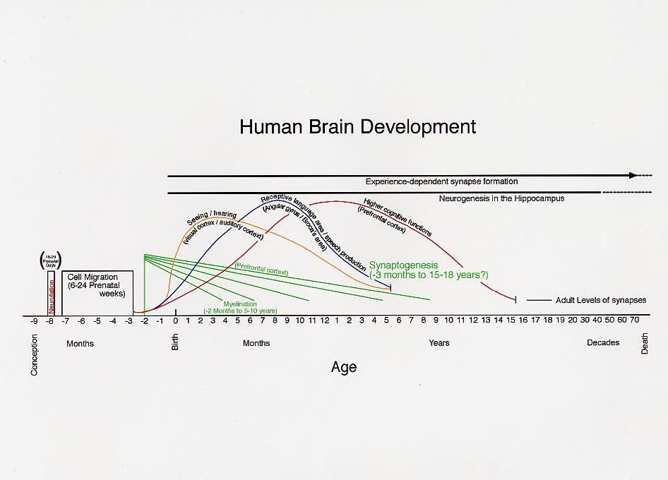

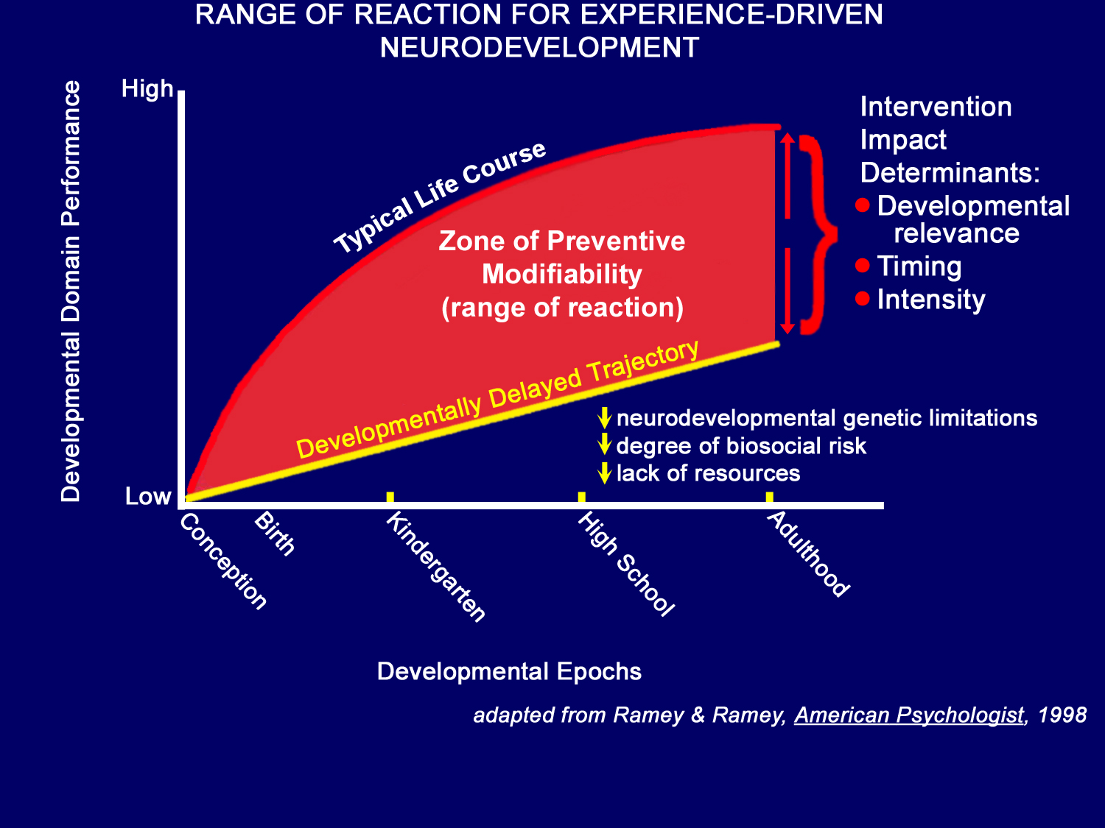
When a child experiences significant trauma, the child becomes overwhelmed and may dissociate; be hyper-vigilant and/or hyperactive, which may be expressed by disturbed sleep, appetite or concentration. To the earliest interactive experiences, the brain responds by organizing its own and developing self-regulation including attention, cognition, mood, anxiety and impulse. Failed self-regulation can lead to clinical syndromes. Further, the plasticity of brain architecture decreases over time because brain circuits consolidate with increasing age, making them more difficult to rewire. The timetable of brain plasticity varies; it is narrow for basic sensory abilities, wider for language, and broadest for cognitive and social-emotional skills. Early plasticity makes the young brain both more vulnerable to harm and more capable of recovery. At all ages it is more efficient – biologically and economically – to prevent later difficulty than to try to remedy problems that emerge.

Opportunities to Address the Problem
- Enhance curricula and other training resources for social workers, court staff, caregivers and other community partners to recognize and respond to the impacts of traumatic stress
- Incorporate scientific research into state and local politics and practices in order to promote positive development and prevent future maltreatment
- Eliminate fragmentation and duplication of services for young children and their families
- Encourage cross systems collaboration between local and state departments and
- Formalize agreements between child welfare and other public agencies, community partners in order
- Cultivate a system that provides timely, appropriate and quality services that can reduce the impact of trauma on young children in foster care.

Contextual Opportunities
- The need to know more about children outside of specific departments becomes significant as Child Welfare Services becomes more outcomes-focused” improve the ability to share meaningful data
- Program Instructions from various Federal Partners regarding foster children specific focus on trauma and well-being), such as those from the Administration for Children and Families, Center for Medicare and Medicaid Services, Substance Abuse and Mental Health Services Administration and the American Academy of Pediatricians
- Katie A. Implementation promotes screening, assessment, treatment and improved coordination between mental health and child welfare systems using child and family teams
- Affordable Health Act offers primary prevention and home visitation programs

Recommendations
- State and local agencies raise the level of awareness regarding the needs of children ages zero to five in foster care
- State and local agencies develop specialized supports and services for this vulnerable population
- State and local agencies identify benchmarks/indicators at the state and local levels to track the system’s success

Proposed Ultimate Goals for the Child Welfare Council
- Provide the leadership and forums to increase statewide awareness that will lead to the development of a plan for action.
- Support a system that promotes healthy development of infants and toddlers placed in out-of-home care.

Justice Raye facilitated a brief discussion of the presentation, including Council members who shared their experiences with young children whose brain development had been compromised by early trauma. He then thanked Cheryl and Penny for their informative presentation, and stated he looked forward to the presentation of recommendations at the December meeting.

- Prevention and Early Intervention Committee/Federal Child Welfare Financing Reform (Status Report)
Secretary Dooley called on Lori Clarke (who was filling in for Kathy Icenhower) and Don Pickens to present the item. Lori summarized the Committee’s efforts to develop a report on federal child welfare finance reform by describing the two subcommittees working on the issue, one on producing educational materials and the other on a framework for recommendations. The key message of both is that federal funding and policy should be better aligned, with the driver being smarter investments. Don, who chairs the subcommittee that is working on educational materials, stated that his group is creating user-friendly materials that clearly lay out what is meant by federal finance reform and the key messages. Once the messages are completed, the group will create fact sheets and FAQs to help inform interested parties. Don explained that while Parent Partners may not know all the technicalities of policy and funding, they do appreciate that investing child welfare funds in prevention to prevent the need for removal of children from their parents is a positive direction for families.

- Approval of Council’s Co-Sponsorship of “Keeping Kids in School and Out-of-Court Summit (Action Item)
In order to ensure Council members were on board with three significant events that would be occurring in December 2013, Justice Raye called on Sylvia Pizzini go clarify that:
- Beyond the Bench Conference will take place all day on December 2 and 3 at the Marriott Hotel in Anaheim
- Keeping Kids in School and Out of Court Summit will have pre-summit workshops and presentations for the County teams in attendance from 10:00 to 5:00 on December 3, and the Summit will take place on December 4, also at the Marriott Hotel in Anaheim.
- The Child Welfare Council meeting will take place on December 11 at the Administrative Office of the Courts, 2860 Gateway Oaks Drive, Suite 400, Sacramento.

Justice Raye then called on Judge Stacy Boulware Eurie and Gordon Jackson to present a proposal for the Council to be a co-sponsor of the Keeping Kids in School and Out of Court Summit. They explained that the Summit has been a collaborative effort of the Blue Ribbon Commission and the Child Welfare Council and will bring together judicial officers, educators, juvenile justice and child welfare professionals, and community leaders to put a spotlight on the problem of truancy and school discipline policies creating a "school-to-prison pipeline" for California's children and youth; to highlight some successful solutions to the problem; and to engage local teams to return to their home counties with a strategy to keep kids in school and out of court. Both she and Gordon participated in the planning as members of the joint Blue Ribbon/Child Welfare Council Task Force. To date, more than 30 California counties had signed up to bring multidisciplinary teams of up to eight members to the event, which is being funded through philanthropic and federal government grants. Summit follow-up will include seeking funding to provide activities to reinforce these initial efforts for schools, courts, and other members of county teams. Activities may include implementing successful initiatives in the schools and courts, working with county teams to focus county strategies, tracking data for judicial officers, and providing continuing education on the issue.

A vote to co-sponsor this event means that the Child Welfare Council, in its capacity as an advisory body responsible for improving the collaboration and processes of the multiple agencies and the courts that serve the children in the child welfare system, endorses the event. Furthermore, such a vote communicates the Council's support of the belief that addressing these issues is important for this state because this work will help build a brighter future for California's children, youth, and families. Council members will be invited to the Summit and to the reception the evening before the Summit.

After a brief discussion, Justice Raye called for a consensus vote which was obtained.

- Status Reports from Committees and Task Forces
- Prevention/Early Intervention Committee
Lori reported on behalf of Kathy Icenhower that the work on the federal child welfare finance reform, discussed earlier on the agenda, remains the main focus of the Committee.
- Permanency Committee
Bob Friend and Carroll Schroeder reported that the Committee would now turn to supporting the implementation of the recommendations as approved by the Council earlier on the agenda.

- Child Development and Successful Youth Transitions (CDSYT) Committee
Rochelle Trochtenberg pointed to the morning’s presentations as evidence that the CDSYT Committee continues to make progress in studying and bringing forth information and recommendations on key topics related to our charge, stating that Council members heard from its Partial Credit and Young Children in Foster Care work groups, and, in addition to these two areas of focus, this afternoon the Committee will continue our studies of:
  - Psychotropic drug use among foster youth;
  - Quality of group home care and the issue of whether group homes should be accredited; and
  - Education-related mental health services.
Gordon added that the Committee is also tracking progress of a work group formed by the Department of Health Care Services and Department of Social Services that is focusing on Psychotropic drug use among foster youth so that our respective efforts in this area can inform each other’s work to address this serious problem. He observed that true to the purpose for which the Council was created, the Committee’s areas of focus require collaboration across systems and since our Committee has representation from most, if not all, of the systems involved, we are well-positioned to bring multiple perspectives to addressing the challenges to making collaboration happen.
- Data Linkages and Information Sharing Committee
Barbara Needell shared information about the upcoming California Systems Integration and Interoperability Symposium II, to be held September 23 - 24, 2013 at the Administrative Office of the Courts in Sacramento for the purpose of developing products and deliverables that will serve as a roadmap for California Health and Human Services interoperability. Shel Culp, Chief Deputy Director with the California Office of Systems Integration will be among the featured speakers.
- Prioritization Task Force
Lori Clarke announced that the new Co-Chairs of the Task Force are Dana Blackwell and Frank Mecca and that Michael Wright of The Results Group was joining the staff support team. The Task Force is working with representatives from each of the focus areas for prioritization to plan the Prioritization Summit being targeted to take place in late January or early February 2014.
- Out-of-County Mental Health Task Force
Dina Kokkos-Gonzalez reported that there is continued progress in working out a solution to ensure payments for mental health services provided to foster children who live outside their county of jurisdiction.
- Blue Ribbon Commission/Child Welfare Council Joint Membership
Justice Raye reported that the focus is on the Keeping Kids in School and Out of Court Summit described earlier on the agencda.
- Ending Commercial Sexual Exploitation of Children Action Team
Leslie Heimov announced that the CSEC Action Team members had been selected and that there would be a brief organizing meeting immediately following the Council meeting.

- Public Comment and Adjournment to Committee Meetings
There being no further comments, Justice Raye and Secretary Dooley thanked everyone for their participation and officially adjourned the meeting.

