Assessing the Impact of Alzheimer’s Disease Research Awards (ADRA) Survey Highlights
Alzheimer’s Advisory Committee Meeting
March 19, 2015

Overview:
- Of 35 invitations to past grant recipients, we received 16 responses (45.7% response rate).

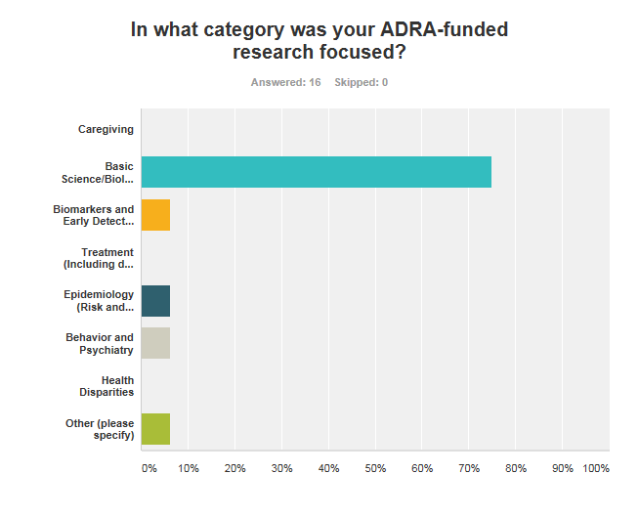
The vast majority of the 16 respondents (75%) were in the field of basic science and biology.

How has your ADRA research grant impacted your future research and the field of Alzheimer's Disease as a whole?
- The ADRA research grants have allowed researchers to explore new ideas, and use the results generated to obtain further research grants to perform additional research in related fields. The majority of respondents (62.5%) reported that they did not receive supplemental grants for their ADRA-funded projects, but have since received grants (ADRA/NIH) for additional research projects. Many of the researchers (87.5%) have published their results in peer-reviewed journals, and have been cited numerous times. Fifty percent (50%) of respondents had more than 21 peer-reviewed articles cite their ADRA-supported publications.
Some notable quotes on how the ADRA research grant impacted future research and the field of Alzheimer’s disease research:
- “My work provided the first definitive evidence that amyloids related to Alzheimer's disease as well as other amyloid-related neuro-degenerated diseases form ion channels that underlie basic pathophysiological abnormality”.
- “My ADRA project initiated my career in Alzheimer research on Amyloid precursor protein in animal models”.
- “I have authored or co-authored 16 peer-reviewed papers in this area since receiving the ADRA grant”.
- “The ADRA grant awarded to me has supported a project that was not yet mature and difficult to be supported by the National Institute of Health at that time. Because of this grant, we successfully made nice progress to develop a unique series of compounds that serve as amyloid ligand and drug candidates”.
- “My ADRA grant explored a novel method, which we hoped would lead to development of novel compounds with high therapeutic and diagnostic potential. During the course of the study, we encountered an unexpected problem. The compounds we developed had intrinsic, high, non-specific binding for unwanted targets that made their use for the specific goal we envisioned impossible. We published the results and have been warning other researchers from these pitfalls to prevent waste of time and efforts by others who wished to explore a similar research direction”.
- “We have used the results of this work in subsequent grant applications, implementation demonstrations, and statewide policy-relevant documents, now for a number of years since completing this work”.

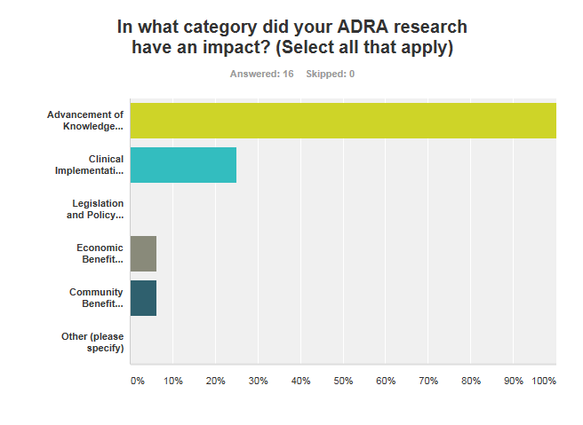
All respondents stated that their projects provided advancement in knowledge regarding Alzheimer’s Disease and Related Dementias, either to support future projects, or to prevent future researchers from encountering the same problems that they did.

What do you feel is the value of the ADRA program for researchers in California?
- The ADRA program is essential for researchers in California. Often times, the proposed research is novel, and would be unable to be funded by the NIH. The ADRA allows for researchers to conduct work that can lead to larger NIH-funded projects in the future. Furthermore, it also allows new scientists to initially start their research in the area of Alzheimer’s disease and related dementias.
Some notable quotes of the value of the ADRA program:
- “To allow research that would not be carried out because of low funding rate for NIH grants”.
- “California should lead the nation-wide Alzheimer's research and the ADRA gives us a competitive edge”.
- “Provides support for focused work that can yield much more benefit in subsequent work as a result of this focused work”.
- “Research funding for Alzheimer's disease is severely limited and currently is only ~10% of the national cancer research budget. This is despite statistics showing that Alzheimer's numbers are increasing at alarming rates, whereas cancer patient numbers are declining, and the fact that to date many patients recover from cancer, but nobody has ever recovered from Alzheimer's. The ADRA provides highly important funding for research in an area that is a huge public health problem and does not get the attention and dollars it deserves and needs. Without significant investment in Alzheimer's research, the disease will bankrupt the American economy in the next few decades”.
- “ADRA funding enables California researchers to conduct work that may be too risky for the more conservative NIH. With ADRA funding, we can test our more interesting hypotheses and acquire the preliminary data that is necessary to achieve larger scale NIH funding. At the same time, our work advances the field and provides the groundwork for what we all hope will be a cure for Alzheimer's and related dementias”.
- “The ADRA program is essential in supporting the initiation of new projects in AD research, and in obtaining sufficient data to compete for more substantial AD research awards. It's also critical in bringing new investigators into the AD research field. Prior to this award, I had never worked in the AD research field. This award is giving me the support needed to begin to establish an AD research program, which I hope will become an important part of my research program”.
- “As the approach was novel, it was possible to start the project early without a large amount to preliminary data”.

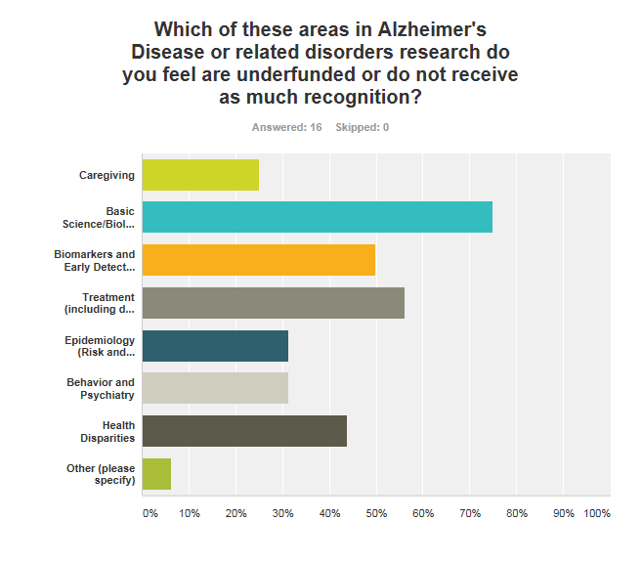
The majority of the survey respondents chose more than one area in Alzheimer’s Disease research that they felt was underfunded. While most thought that basic science was the most underfunded or did not receive enough recognition, there seems to be an inherent bias due to the makeup of the respondents. Of note: one respondent said that the “correct” answer was “all of the above”.

